**MedTrack: AWS Cloud-Enabled Healthcare Management System**

**Project Description:**

In today’s fast-evolving healthcare landscape, efficient communication and coordination between doctors and patients are crucial. MedTrack is a cloud-based healthcare management system that streamlines patient doctor interactions by providing a centralized platform for booking appointments, managing medical histories, and enabling diagnosis submissions. To address these challenges, the project utilizes Flask for backend development, AWS EC2 for hosting, and DynamoDB for managing data. MedTrack allows patients to register, log in, book appointments, and submit diagnosis reports online. The system ensures real-time notifications, enhancing communication between doctors and patients regarding appointments and medical submissions. Additionally, AWS Identity and Access Management (IAM) is employed to ensure secure access control to AWS resources, allowing only authorized users to access sensitive data. This cloud-based solution improves accessibility and efficiency in healthcare services for all users.

**Scenarios:**

**Scenario 1: Efficient Appointment Booking System for Patients**

In the MedTrack system, AWS EC2 provides a reliable infrastructure to manage multiple patients accessing the platform simultaneously. For example, a patient can log in, navigate to the appointment booking section, and easily submit a request for an appointment. Flask handles backend operations, efficiently retrieving and processing user data in real-time. The cloud-based architecture allows the platform to handle a high volume of appointment requests during peak periods, ensuring smooth operation without delays.

**Scenario 2: Secure User Management with IAM**

MedTrack utilizes AWS IAM to manage user permissions and ensure secure access to the system. For instance, when a new patient registers, an IAM user is created with specific roles and permissions to access only the features relevant to them. Doctors have their own IAM configurations, allowing them access to patient records and appointment details while maintaining strict security protocols. This setup ensures that sensitive data is accessible only to authorized users.

**Scenario 3: Easy Access to Medical History and Resources**

The MedTrack system provides doctors and patients with easy access to medical histories and relevant resources. For example, a patient logs in to view their medical history and upcoming appointments. Doctors diagnose conditions and prescribe necessary medications to their patients. Flask manages real-time data fetching from DynamoDB, while EC2 hosting ensures the platform performs seamlessly even when multiple users access it simultaneously, offering a smooth and uninterrupted user experience.

**Architecture**

This AWS-based architecture powers a scalable and secure web application using Amazon EC2 for hosting the backend, with a lightweight framework like Flask handling core logic. Application data is stored in Amazon DynamoDB, ensuring fast, reliable access, while user access is managed through AWS IAM for secure authentication and control. Real-time alerts and system notifications are enabled via Amazon SNS, enhancing communication and user engagement.

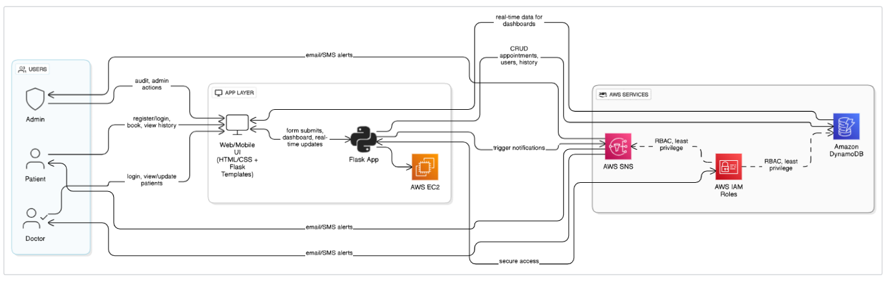

**Entity Relationship (ER) Diagram**

An ER (Entity-Relationship) diagram visually represents the logical structure of a database by defining entities, their attributes, and the relationships between them. It helps organize data efficiently by illustrating how different components of the system interact and relate. This structured approach supports effective database normalization, data integrity, and simplified query design.

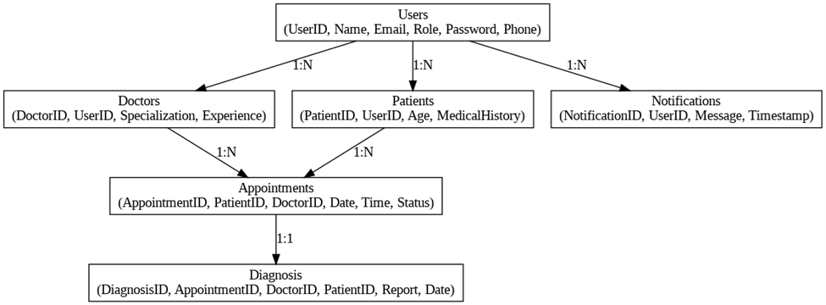

**Pre-requisites**

* AWS Account Setup:  
  <https://docs.aws.amazon.com/accounts/latest/reference/getting-started.html>
* AWS IAM (Identity and Access Management):  
  <https://docs.aws.amazon.com/IAM/latest/UserGuide/introduction.html>
* AWS EC2 (Elastic Compute Cloud):  
  <https://docs.aws.amazon.com/AWSEC2/latest/UserGuide/concepts.html>
* AWS DynamoDB:   
  [https://docs.aws.amazon.com/amazondynamodb/Introduction.html](https://docs.aws.amazon.com/amazondynamodb/latest/developerguide/Introduction.html)
* Amazon SNS:   
  <https://docs.aws.amazon.com/sns/latest/dg/welcome.htm>l
* Git Documentation:   
  <https://git-scm.com/doc>
* VS Code Installation: (download the VS Code using the below link or you can get that in Microsoft store)  
  <https://code.visualstudio.com/download>

**Project WorkFlow**

**Milestone 1. AWS Account Setup and Login**

**Activity 1.1:** Set up an AWS account if not already done**.**

**Activity 1.2:** Log in to the AWS Management Console.

**Milestone 2. DynamoDB Database Creation and Setup**

**Activity 2.1**: Create a DynamoDB Table.

**Activity 2.2**: Configure Attributes for User Data and Book Requests.

**Milestone 3. SNS Notification Setup**

**Activity 3.1**: Create SNS topics for book request notifications.

**Activity 3.2**: Subscribe users and library staff to SNS email notifications.

**Milestone 4. Backend Development and Application Setup**

**Activity 4.1**: Develop the Backend Using Flask.

**Activity 4.2**: Integrate AWS Services Using boto3.

**Milestone 5. IAM Role Setup**

**Activity 5.1**: Create IAM Role

**Activity 5.2**: Attach Policies

**Milestone 6. EC2 Instance Setup**

**Activity 6.1**: Launch an EC2 instance to host the Flask application.

**Activity 6.2**: Configure security groups for HTTP, and SSH access.

**Milestone 7. Deployment on EC2**

**Activity 7.1**: Upload Flask Files

**Activity 7.2**: Run the Flask App

**Milestone 8. Testing and Deployment**

**Activity 8.1**: Conduct functional testing to verify user registration, login, book requests, and notifications.

**Milestone 1. AWS Account Setup and Login**

**Activity 1.1:** Set up an AWS account if not already done**.**

* Sign up for an AWS account and configure billing settings.

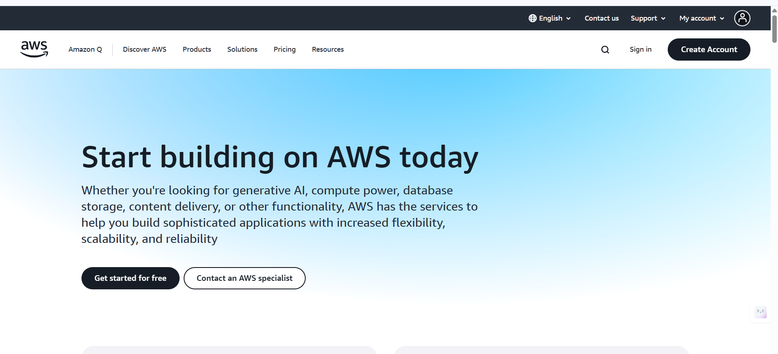

* **Activity 1.2:** Log in to the AWS Management Console

○ After setting up your account, log in to the AWS Management Console.

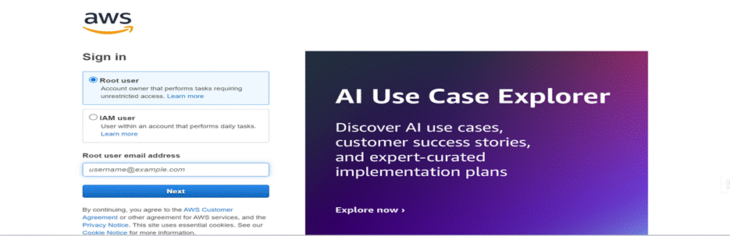

**Milestone 2. DynamoDB Database Creation and Setup**

**Activity 2.1**: Create a DynamoDB Table.

* In the AWS Console, navigate to DynamoDB and click on create tables.  
    
  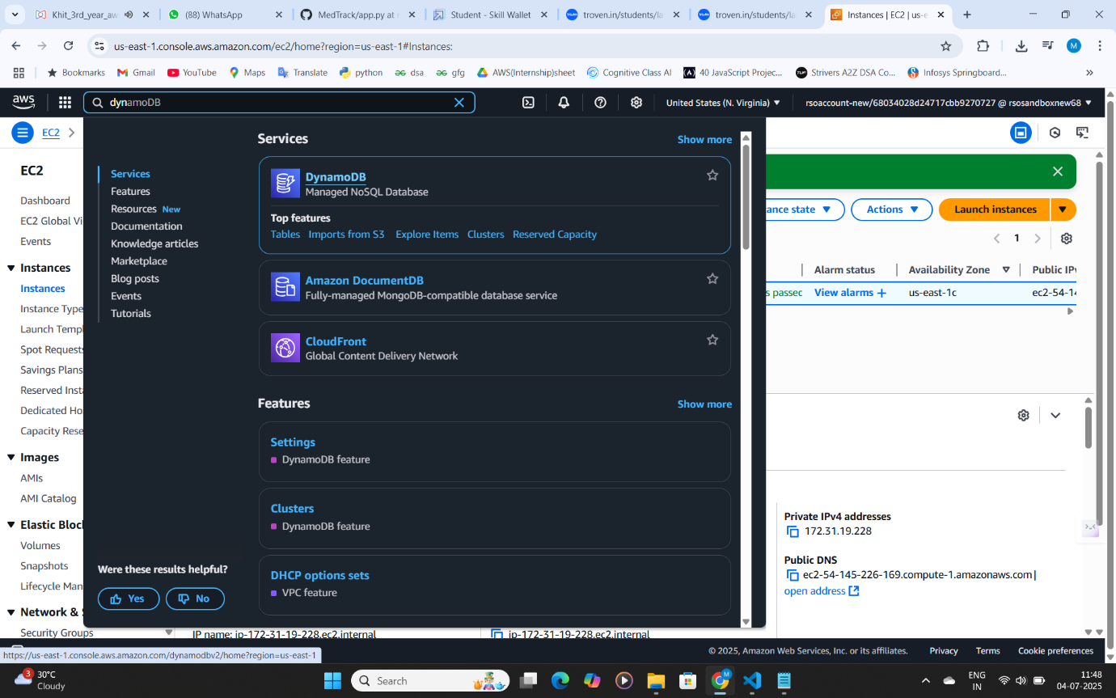

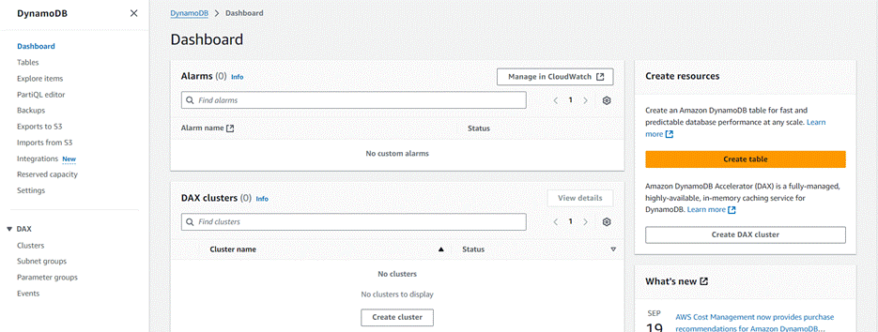

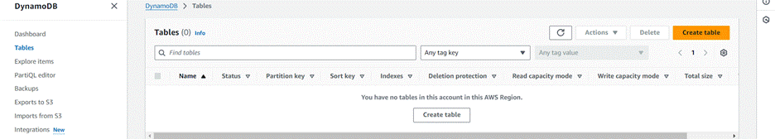

* **Activity 2.2**: Create a DynamoDB table for storing registration details and book requests.
* 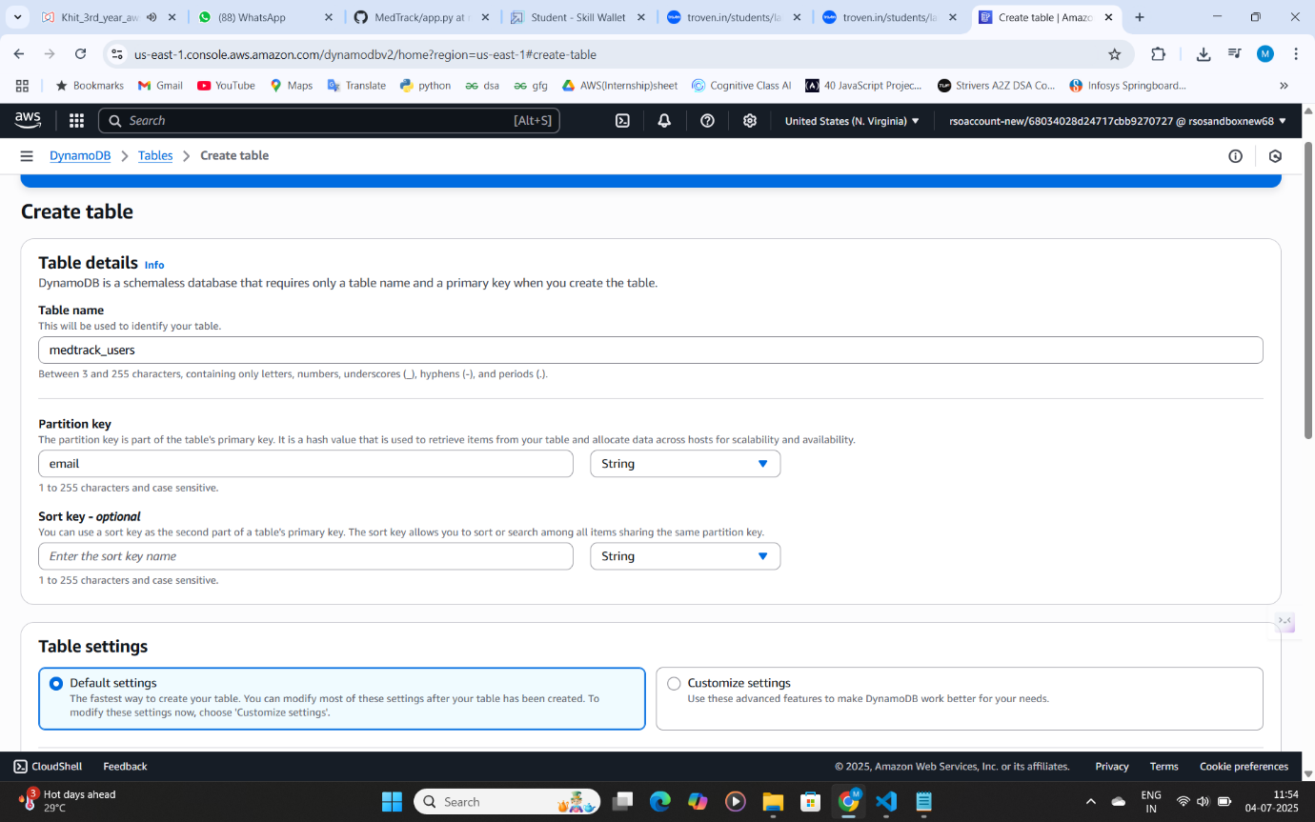Create medtrack_users table with partition key “Email” with type String and click on create tables.

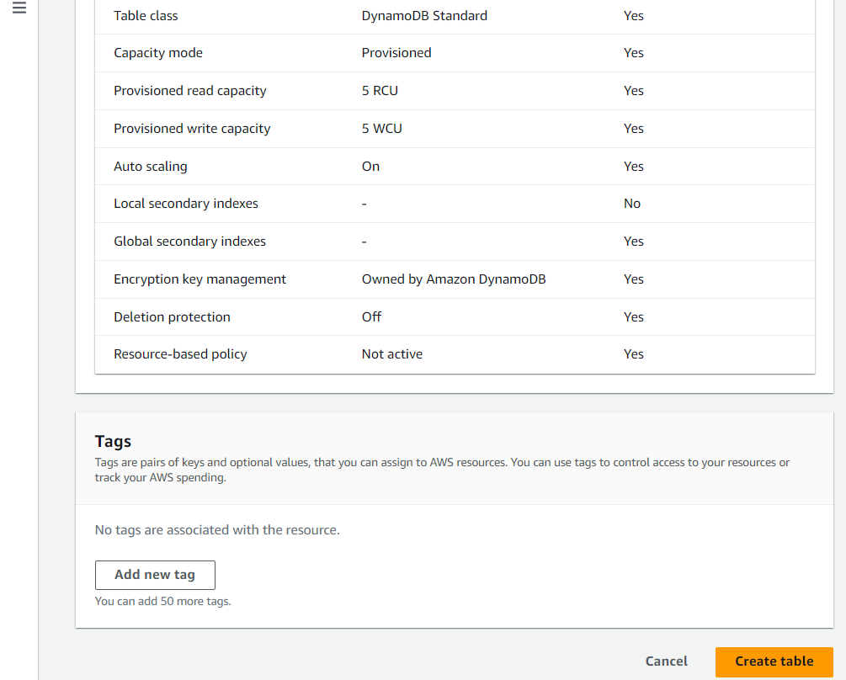

* Create medtrack_appointments Table with partition key “appointment_id” with type String and click on create tables.

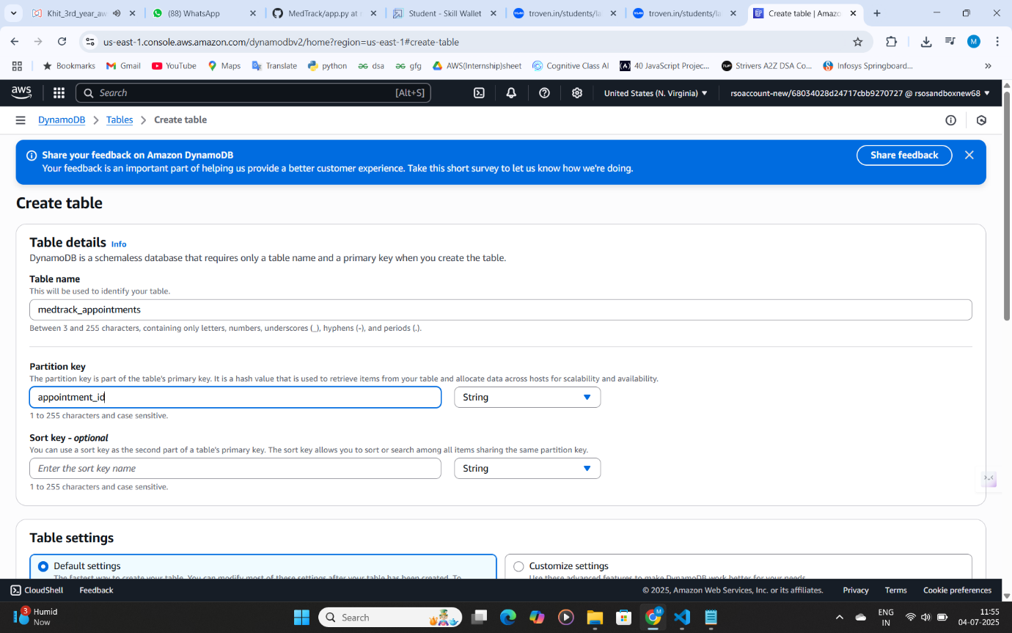



* Create medtrack_prescriptions Table with partition key “prescription_id” with type String and click on create tables.

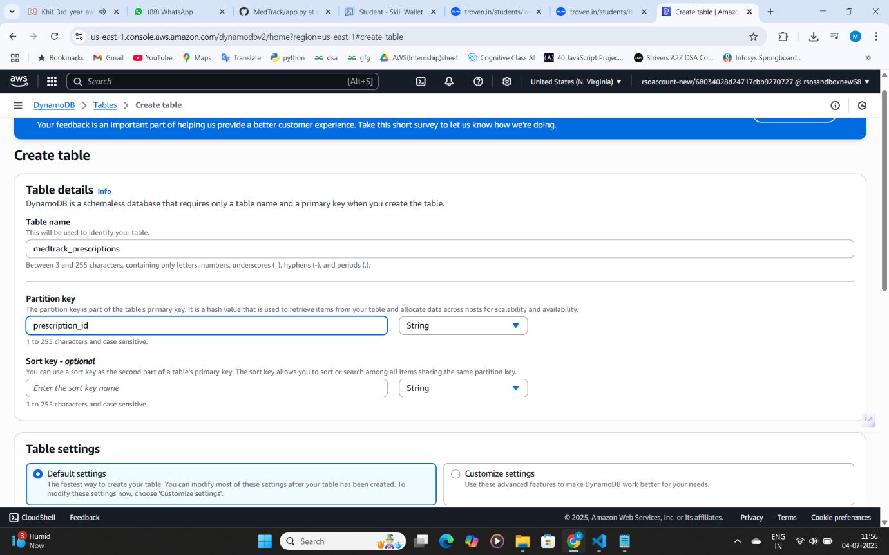

* Similarly Create medtrack_medication_remainders Table with partition key “reminder_id” with type String and click on create tables.

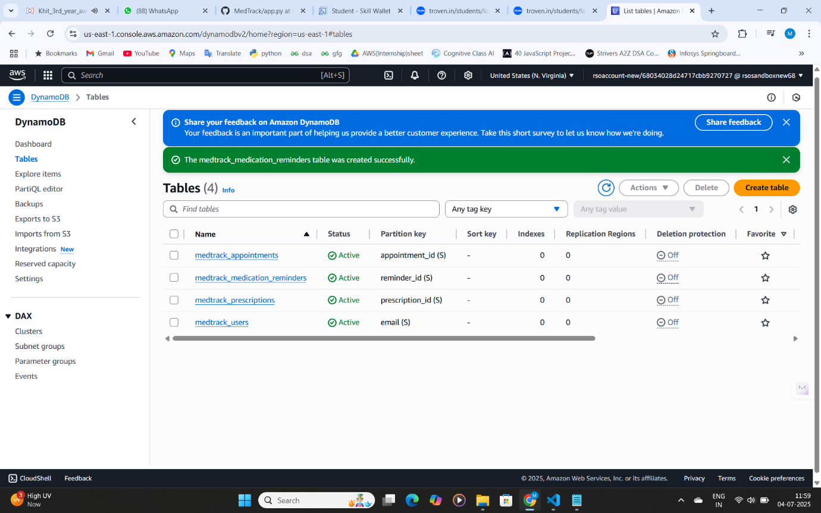

**Milestone 3. SNS Notification Setup**

**Activity 3.1**: Create SNS topics for book request notifications.

* In the AWS Console, search for SNS and navigate to the SNS Dashboard.

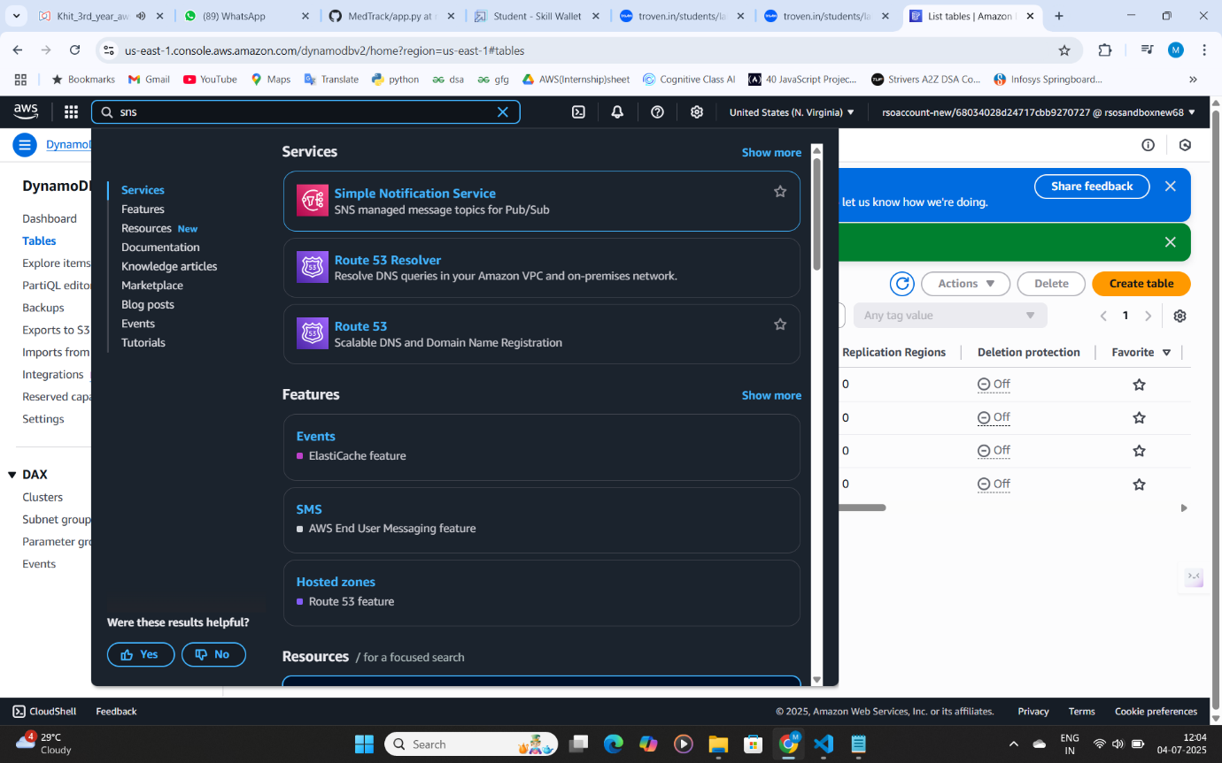

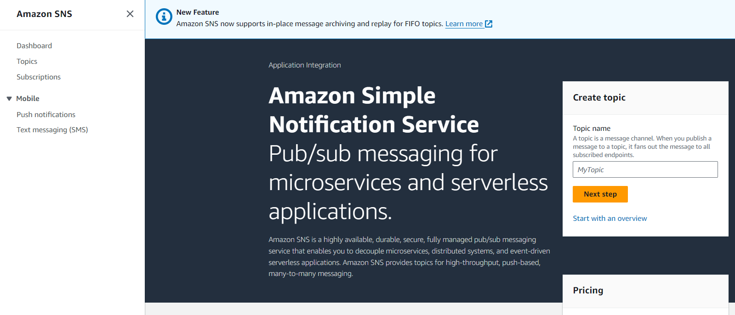

* Click on **Create Topic** and choose a name for the topic.

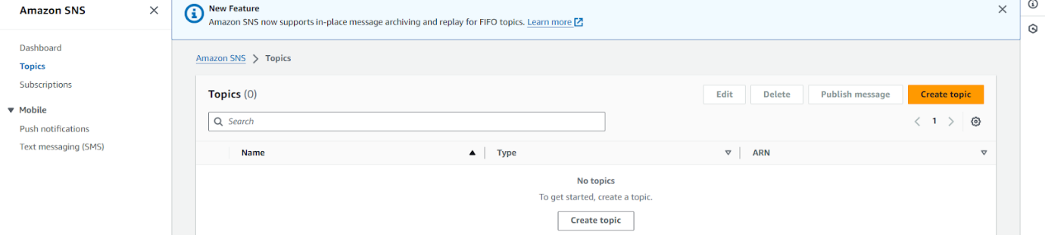

* Choose Standard type for general notification use cases and Click on Create Topic.

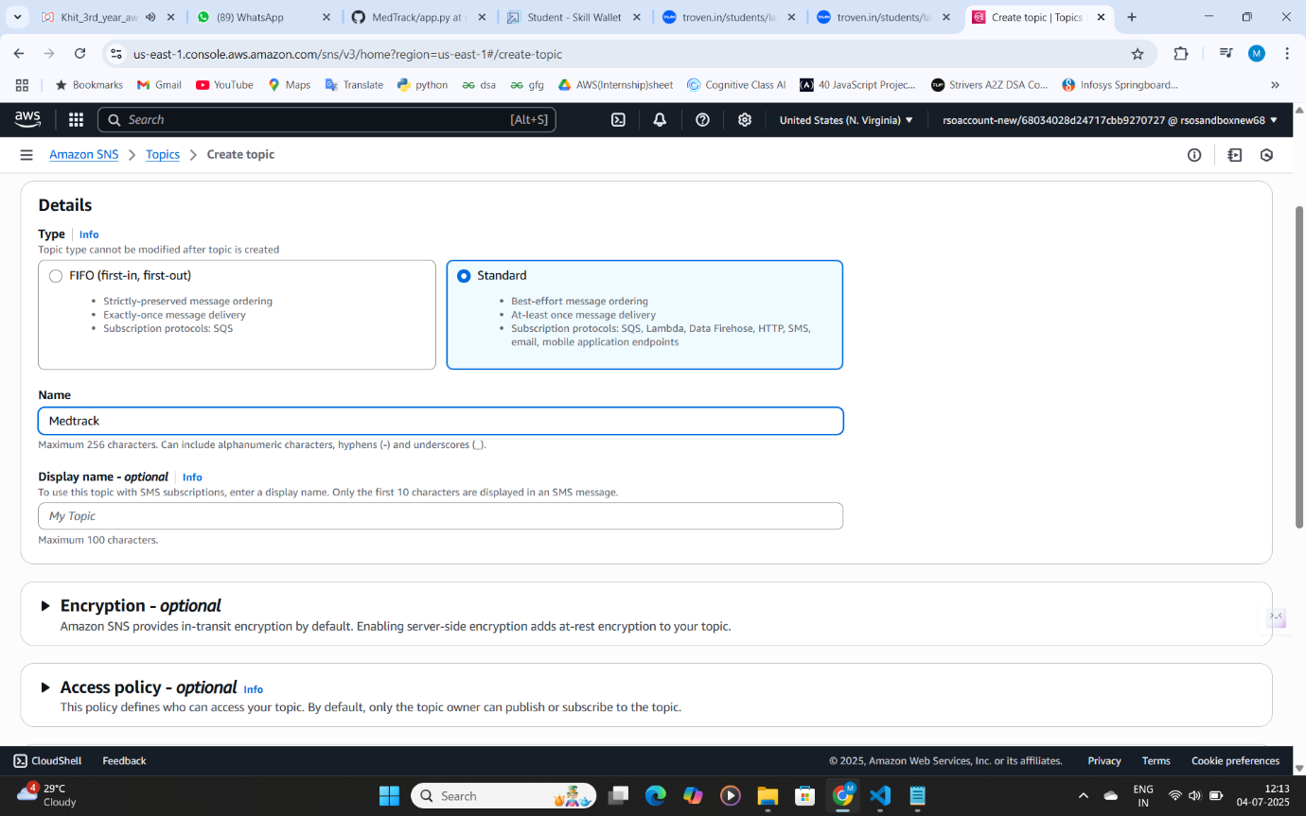

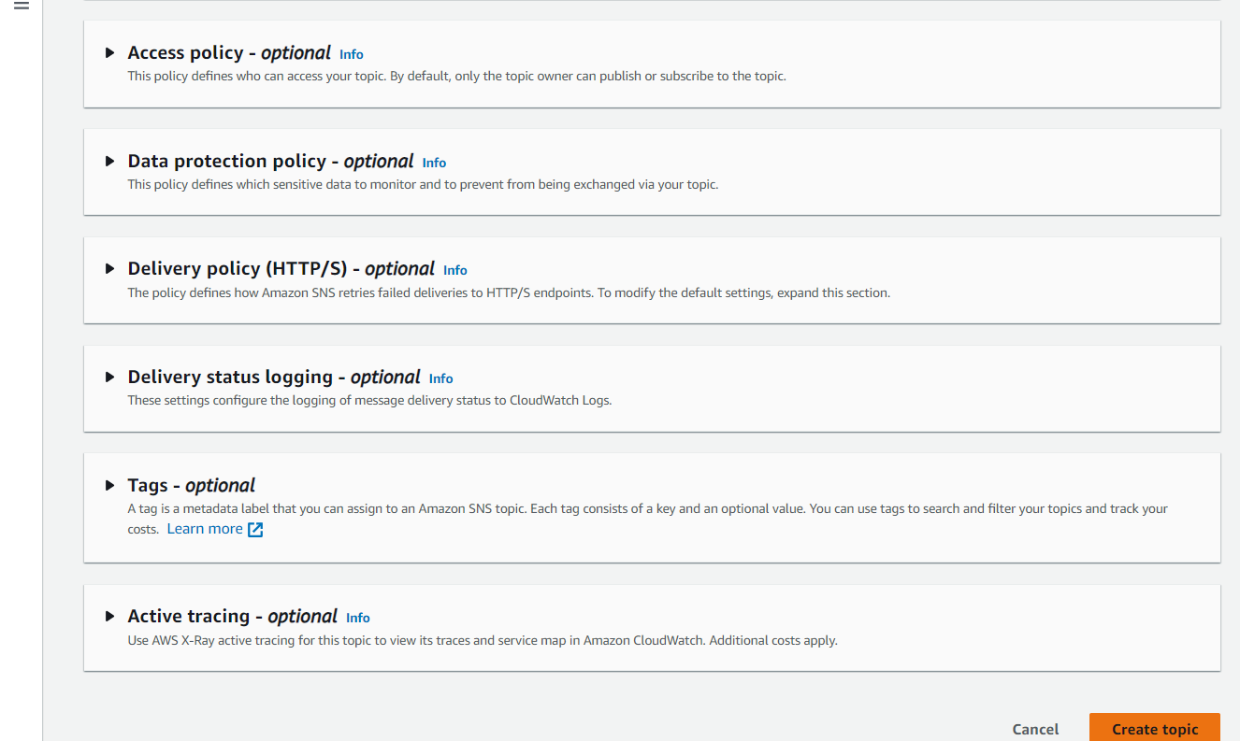

* Configure the SNS topic and note down the **Topic ARN**.

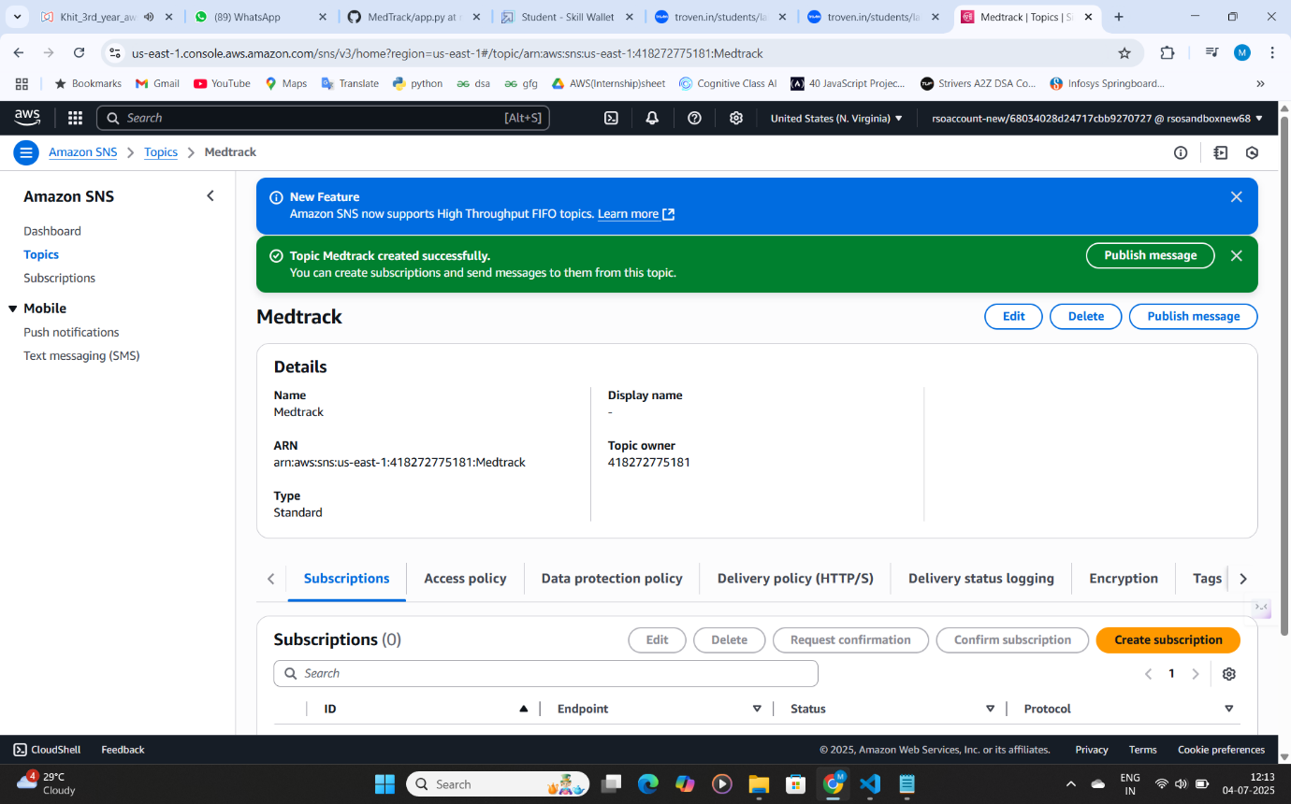

* **Activity 3.2**: Subscribe users and staff to relevant SNS topics to receive real-time notifications when a book request is made.
* Subscribe users (or admin staff) to this topic via email. When a book request is made, notifications will be sent to the subscribed emails**.**

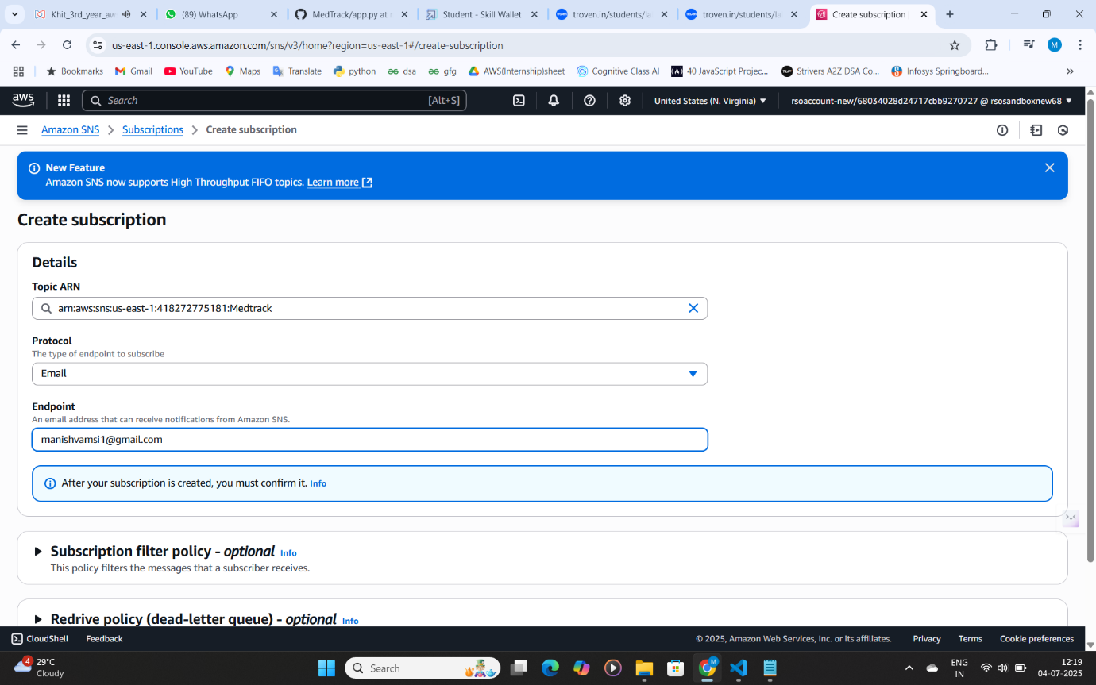

* After subscription request for the mail confirmation
* Navigate to the subscribed Email account and Click on the confirm subscription in the AWS Notification- Subscription Confirmation mail.

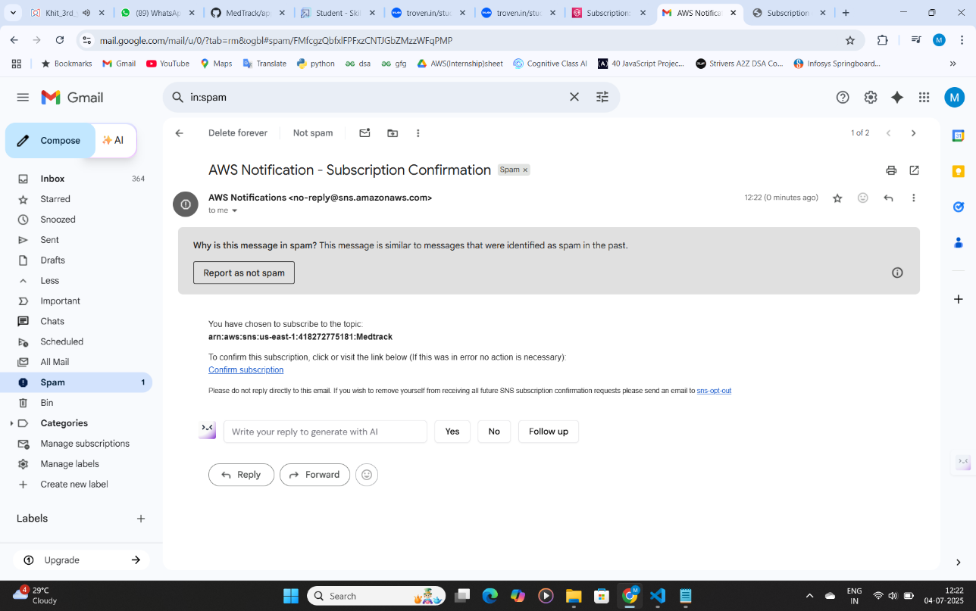

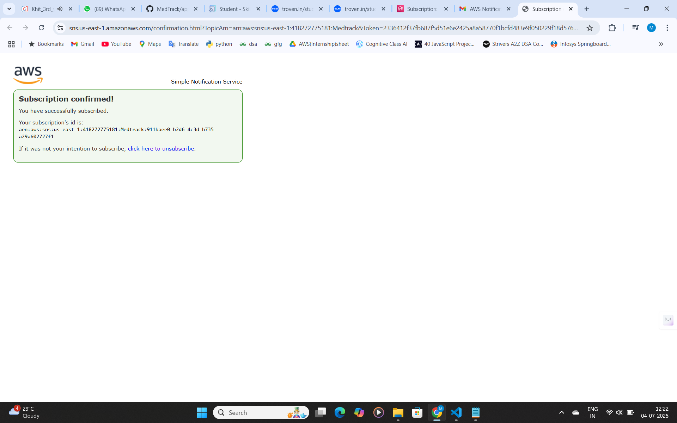

* Successfully done with the SNS mail subscription and setup, store the ARN link.

**Milestone 4. Backend Development and Application Setup**

**Activity 4.1**: Develop the Backend Using Flask.

* File Explorer Structure

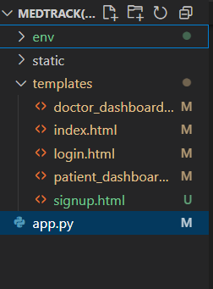

* **Description of the code:**
* **Flask App Initialization:**

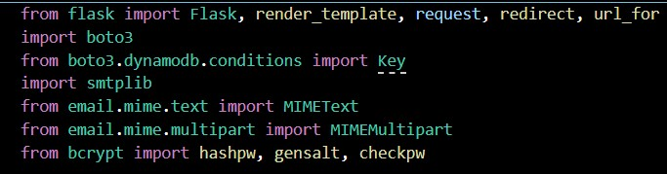

**Description:** import essential libraries including Flask utilities for routing, Boto3 for DynamoDB operations, SMTP and email modules for sending mails, and Bcrypt for password hashing and verification.



* **Dynamodb Setup:**

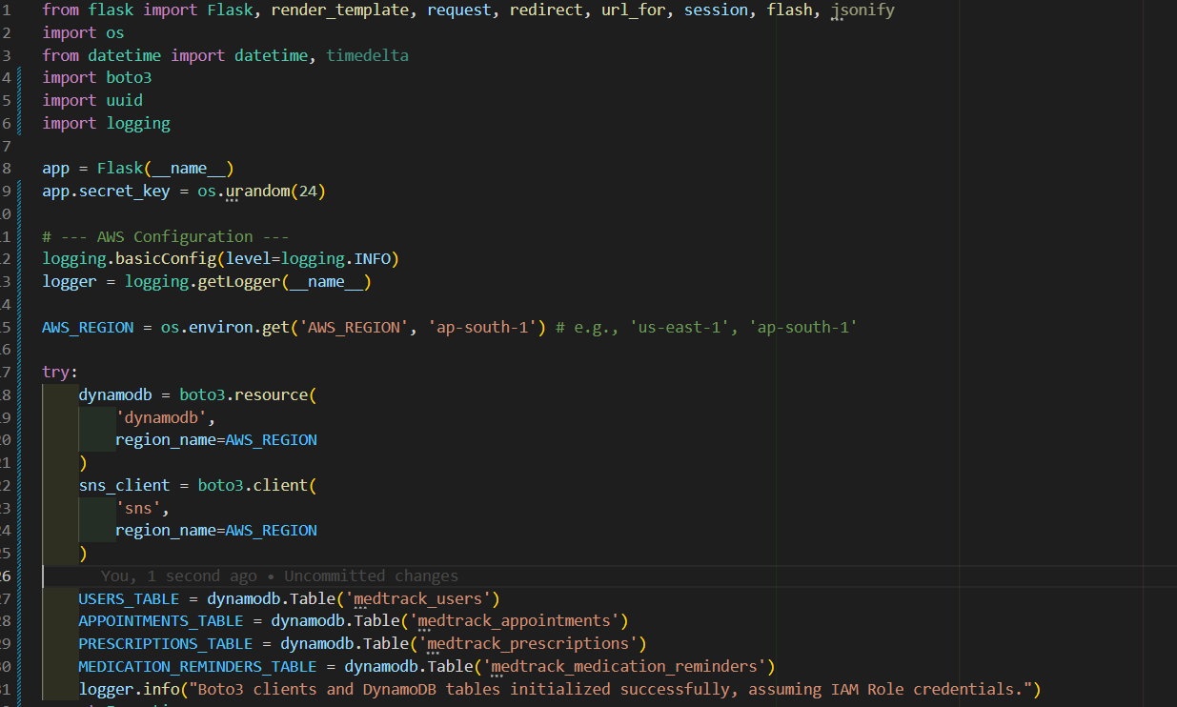

**Description**: Initialize the DynamoDB resource for the ap-south-1 region and set up access to the Users and Requests tables for storing user details and book requests.

* **SNS Connection**

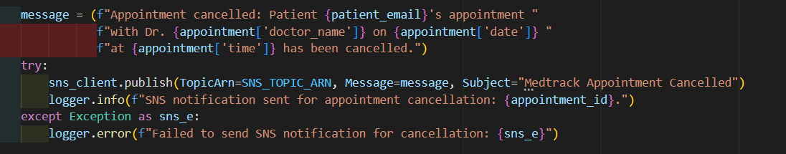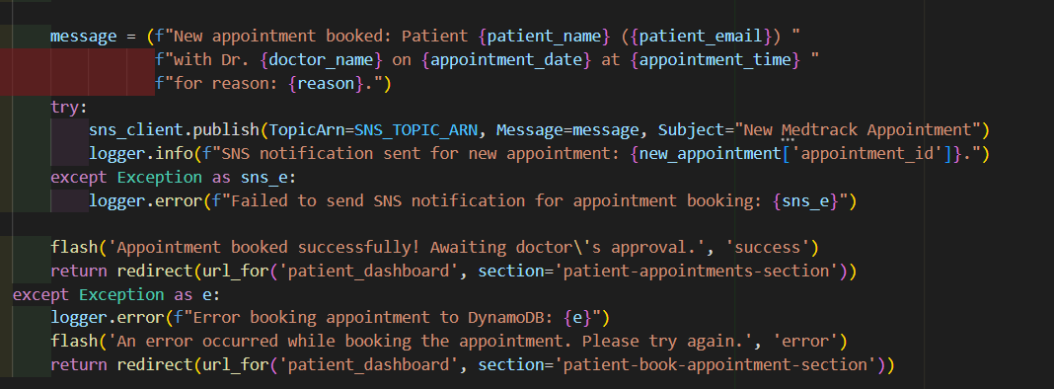

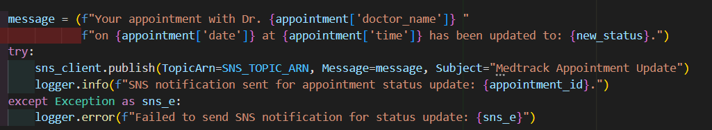

**Description:** Configure SNS to send notifications when a book request is submitted. Paste your stored ARN link in the sns_topic_arn space, along with the region_name where the SNS topic is created.

* **Routes for Web Pages:**
* **Index Route:**

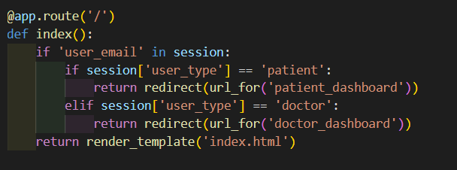

* **Register Route:**

Verifies user credentials, increments login count, and redirects to the dashboard on success.

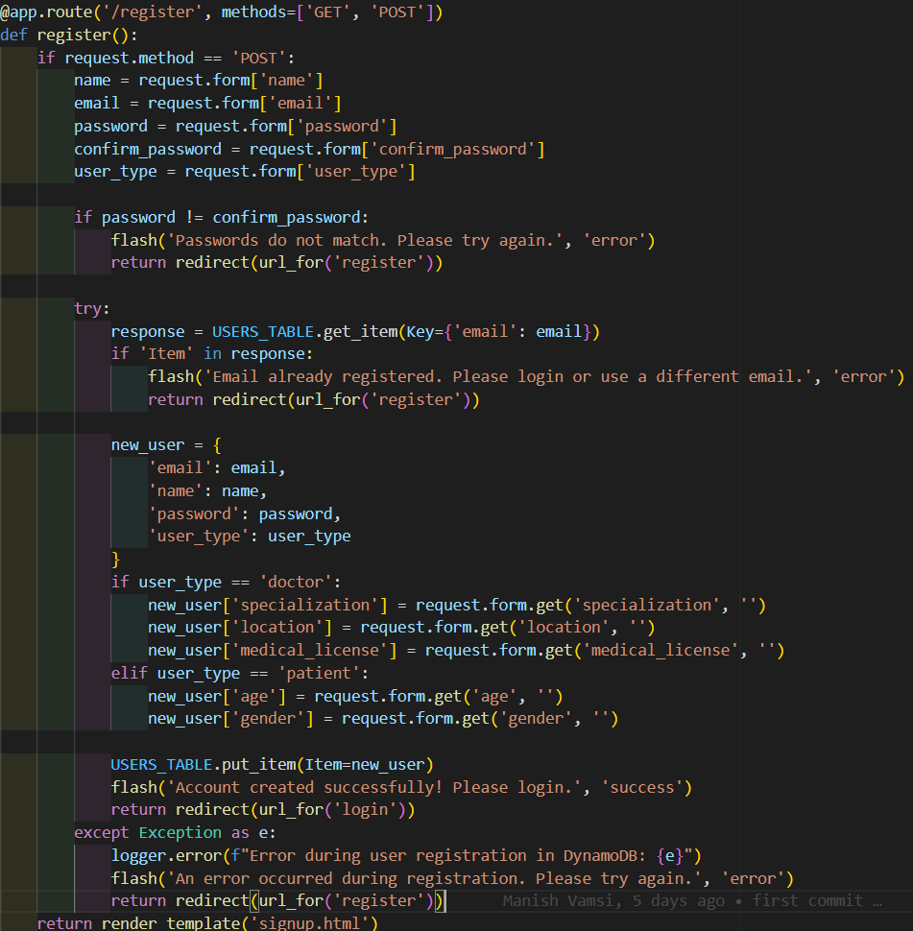

* **Login Route (GET/POST):** The **login route** handles user authentication by verifying credentials stored in **DynamoDB**. Upon successful login, it increments the **login count** and redirects the user to their dashboard.

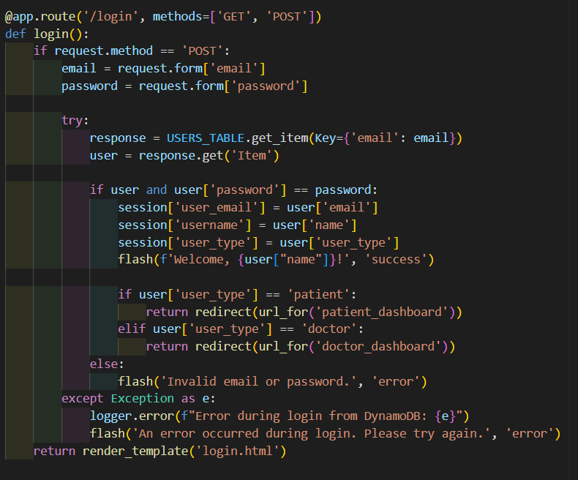

* **Logout Route:** The logout functionality allows users to securely end their session, clearing any session data and redirecting them to the login page.

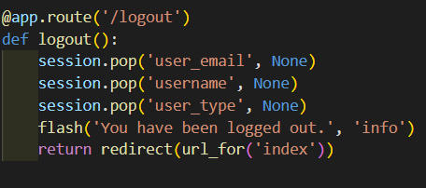

* **Book Appointment Route:** The book appointment route allows users to select a date, time, and doctor for their appointment. Upon submission, the system stores the appointment details in DynamoDB and sends a confirmation notification via SNS.

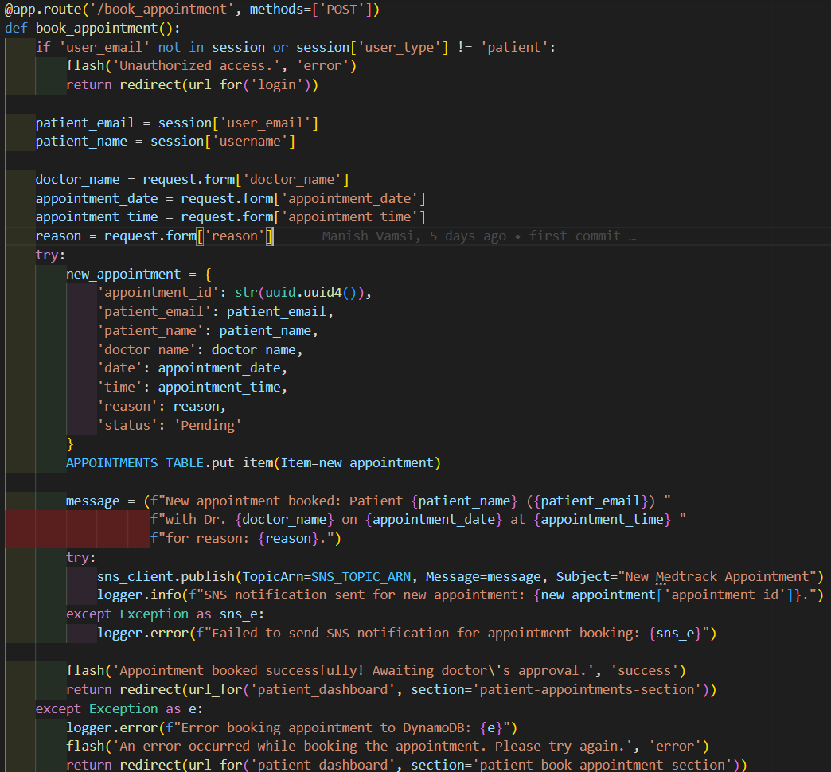

* **Medication Remainder Route:** This route allows patients to set new medication reminders. It saves the medication details, schedule, and optional information to DynamoDB and sends an SNS notification.

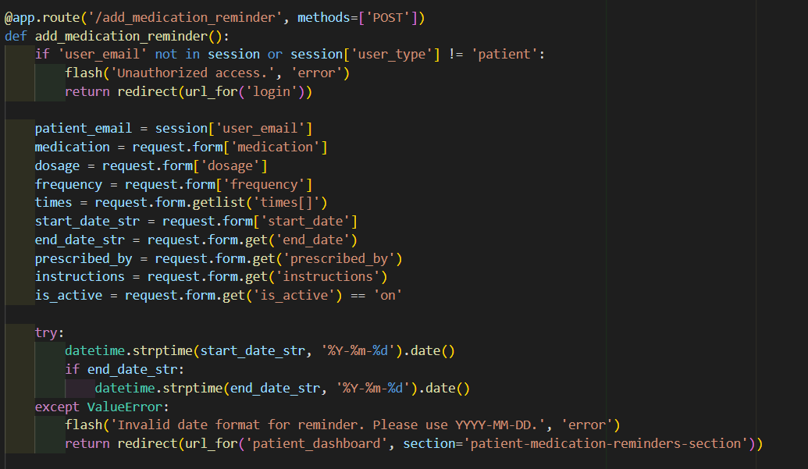

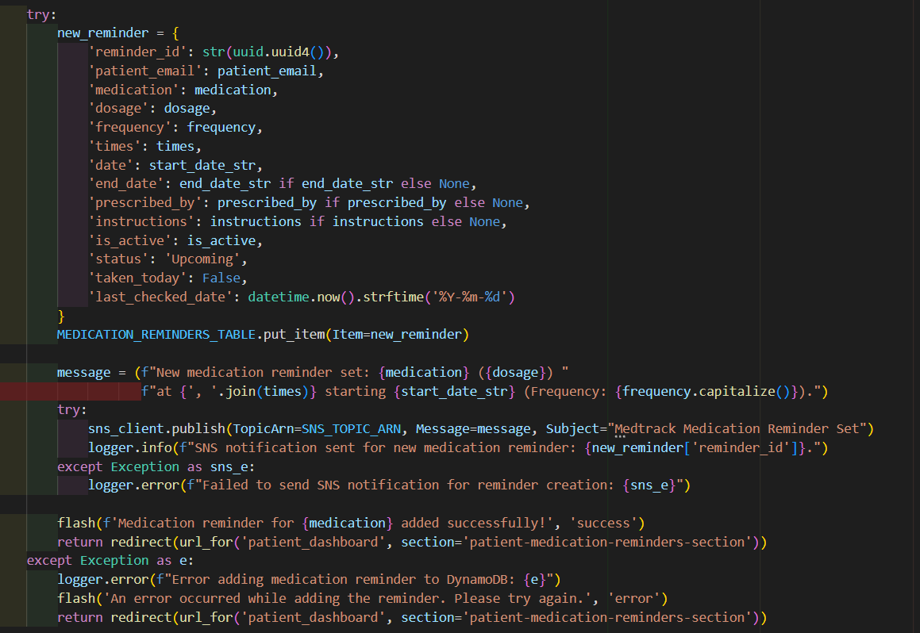

* **Issue Prescription Route:** This route enables doctors to issue new prescriptions to patients. It stores the prescription details in DynamoDB and sends an SNS notification to inform the patient.

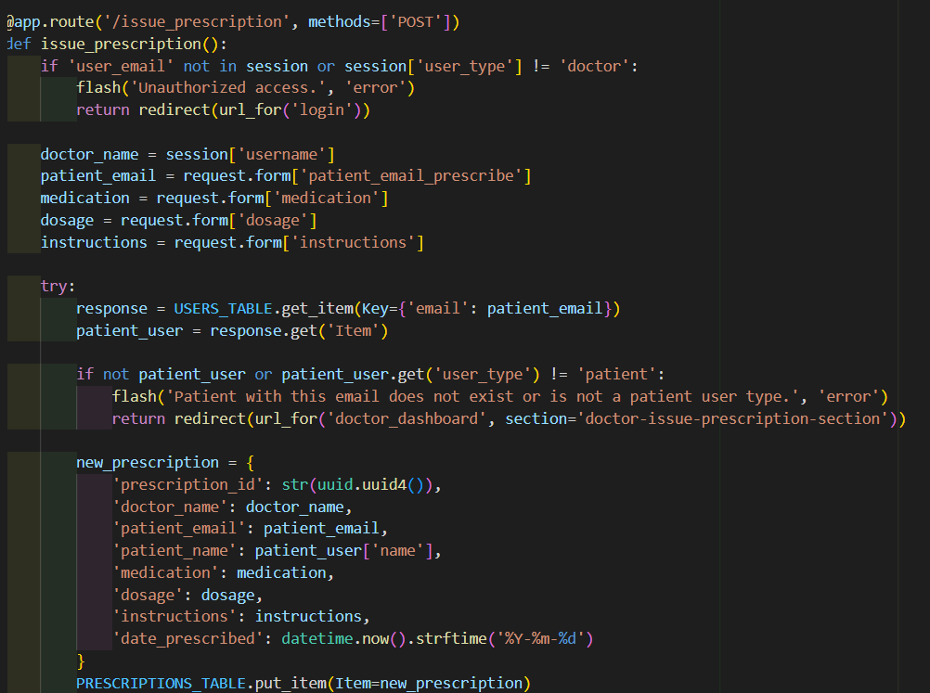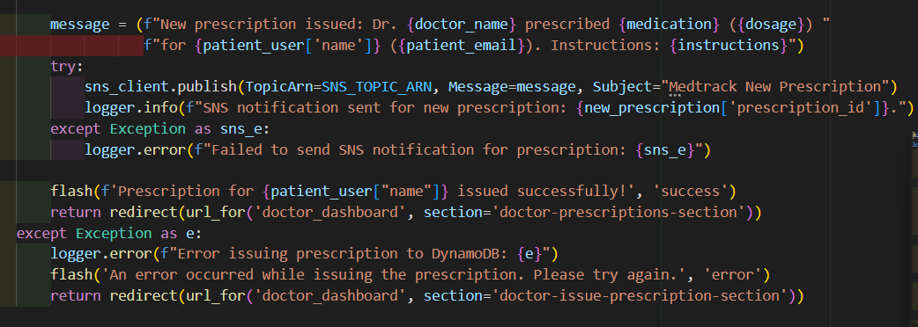

* **Deployment Code:**

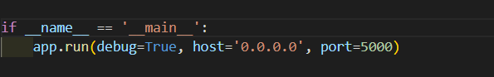

**Milestone 5. IAM Role Setup**

**Activity 5.1**: Create IAM Role

* In the AWS Console, go to IAM and create a new IAM Role for EC2 to interact with DynamoDB and SNS.

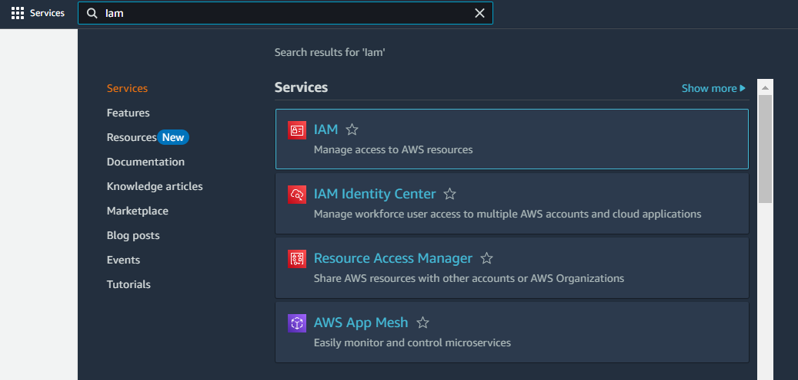

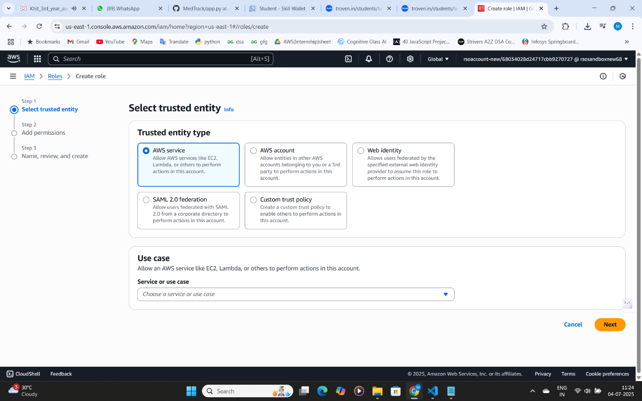

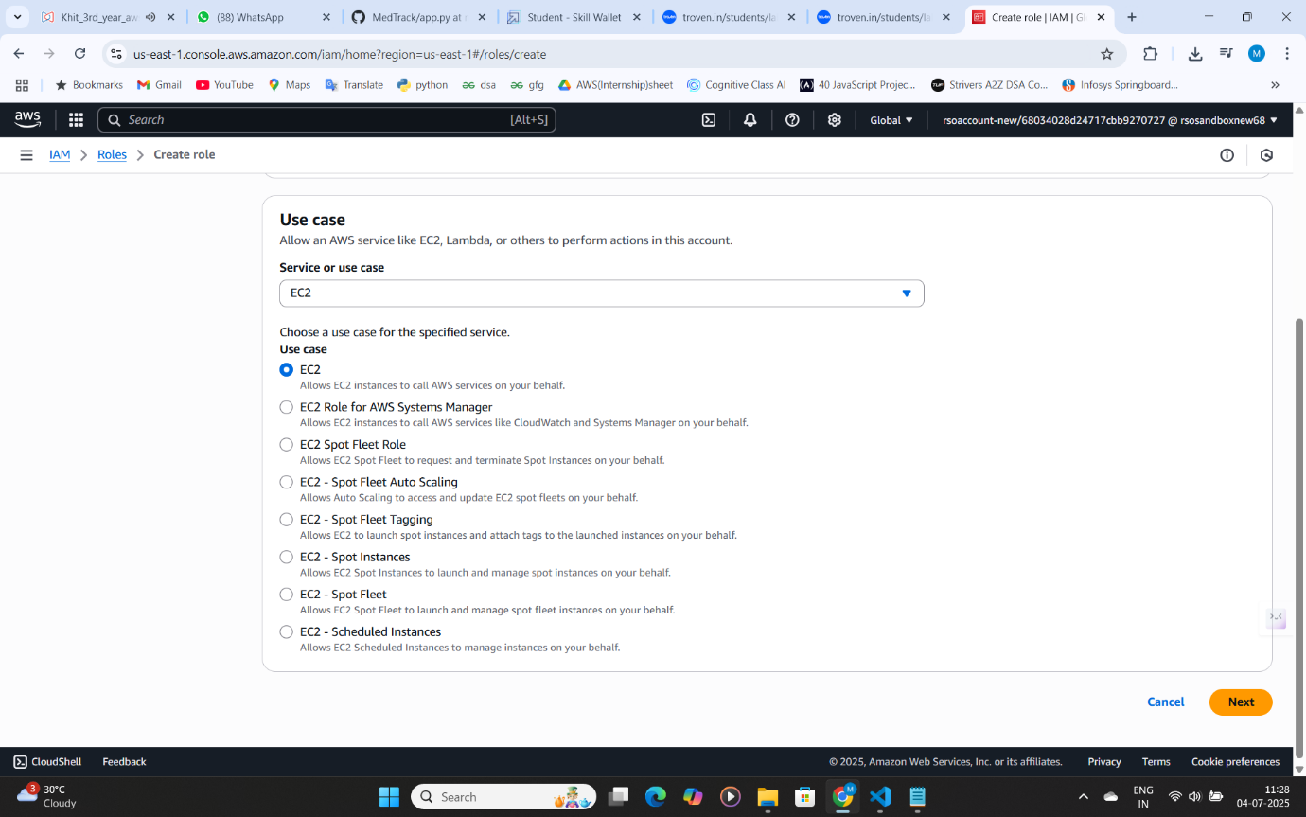

* **Activity 5.2: Attach Policies.**

Attach the following policies to the role:

* AmazonDynamoDBFullAccess: Allows EC2 to perform read/write operations on DynamoDB.
* 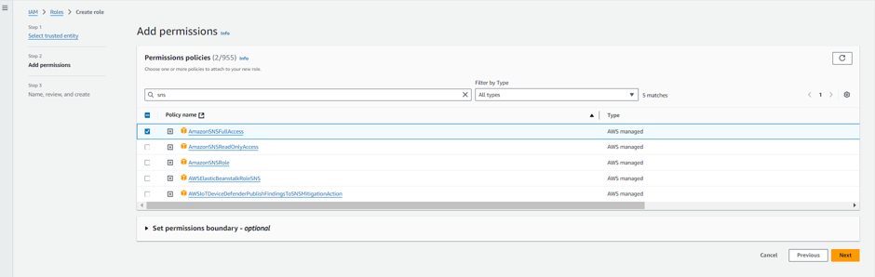AmazonSNSFullAccess: Grants EC2 the ability to send notifications via SNS.

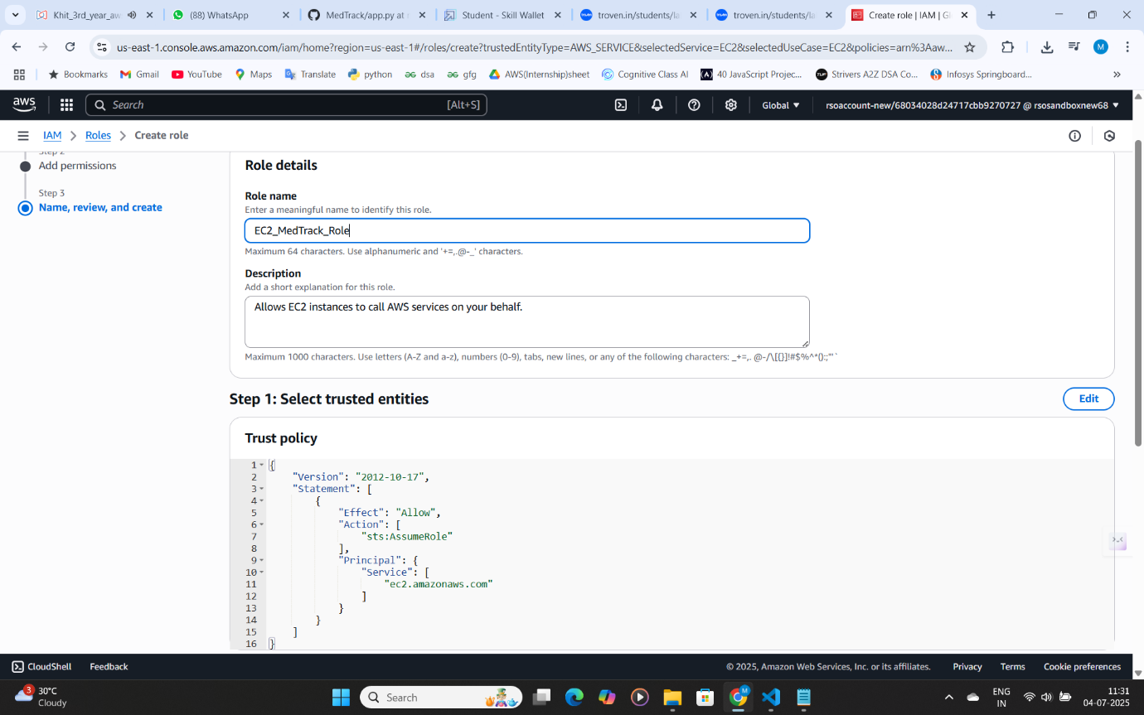

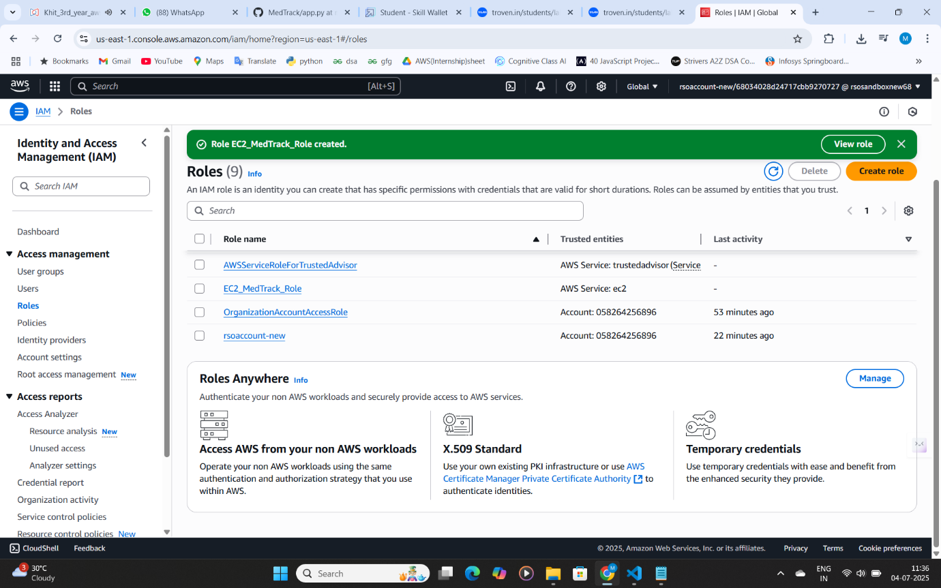

* **Milestone 6. EC2 Instance Setup**
* **Note:** Load your Flask app and Html files into GitHub repository.

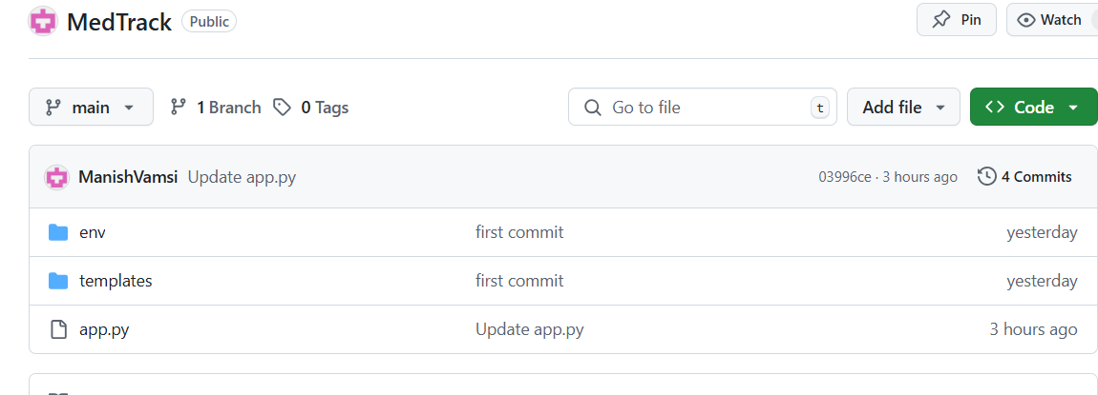 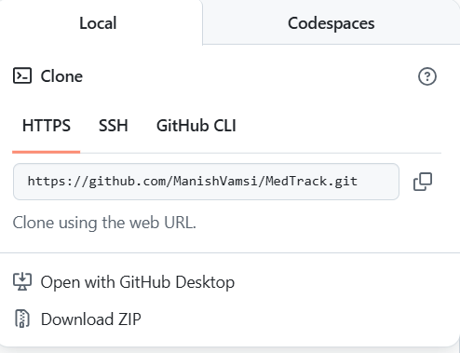

**Activity 6.1**: **Launch an EC2 instance to host the Flask application.**

* **Launch EC2 Instance**
  + In the AWS Console, navigate to EC2 and launch a new instance.

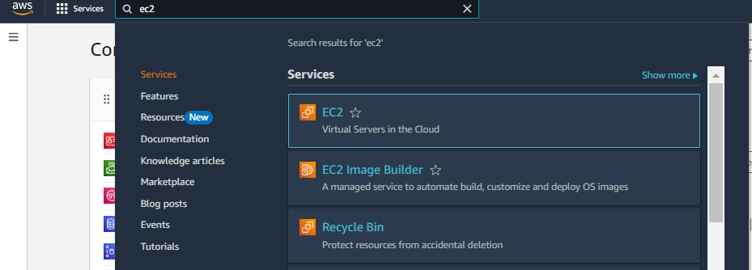

* Click on Launch instance to launch EC2 instance

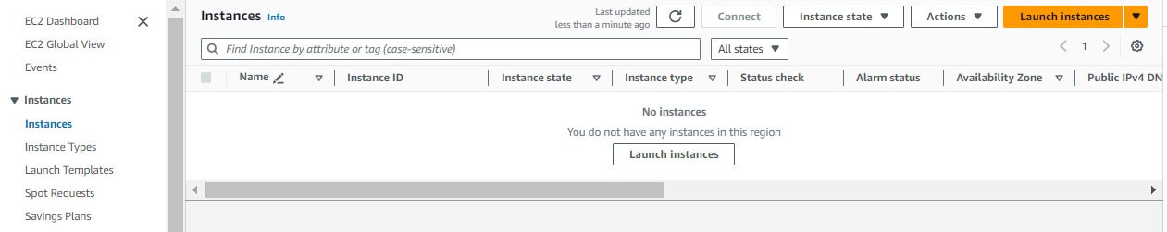

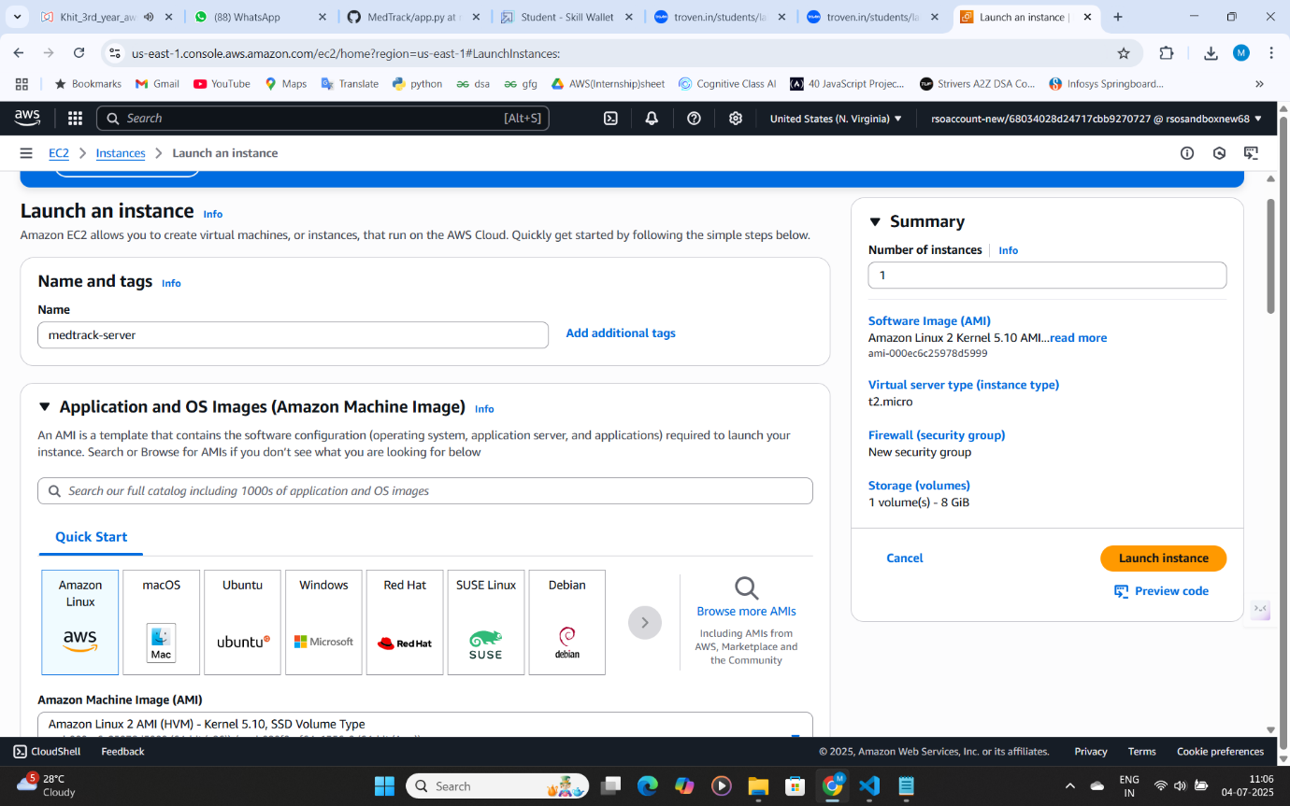

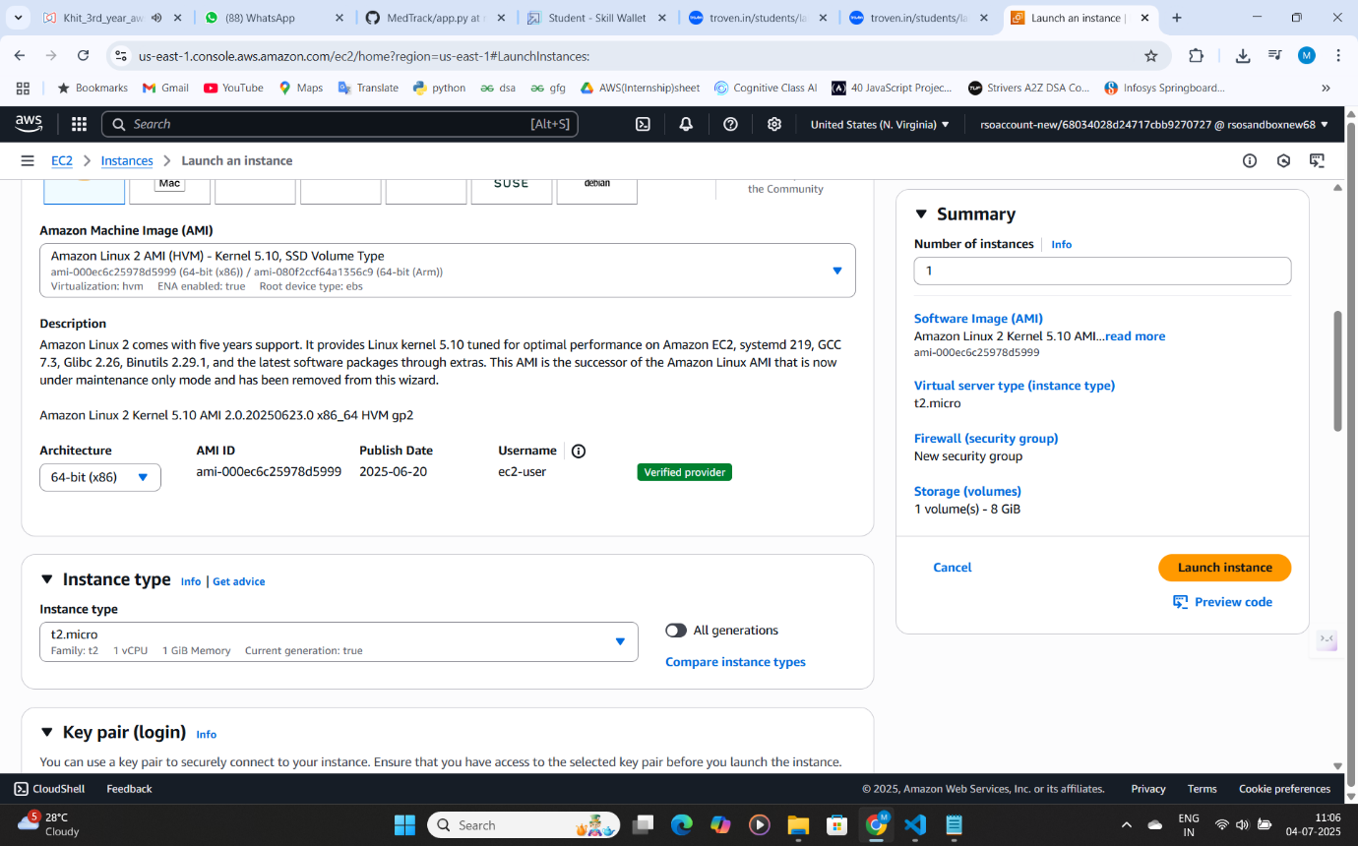

* Create and download the key pair for server access:

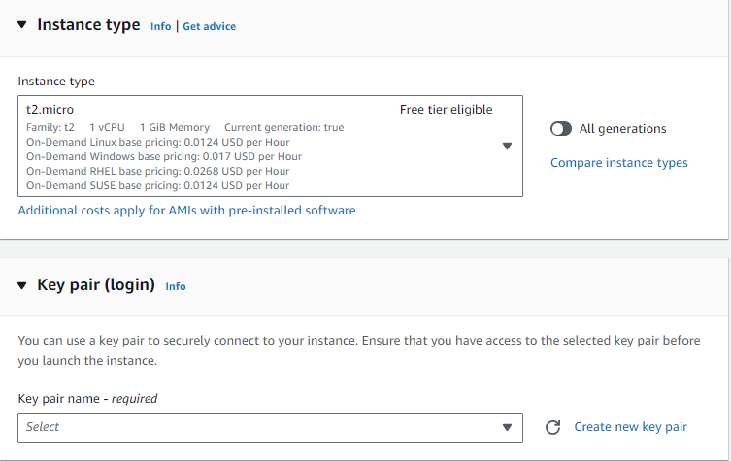

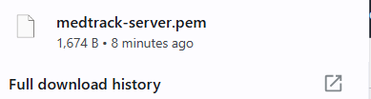

* **Activity 6.2: Configure security groups for HTTP, and SSH access.**

For network settings during EC2 instance launch:

1. In the **Network Settings** section, select the **VPC** and **Subnet** you wish to use (if unsure, the default VPC and subnet should work).
2. Ensure **Auto-assign Public IP** is enabled so your instance can be accessed from the internet.
3. In **Security Group**, either select an existing one or create a new one that allows SSH (port 22) access to your EC2 instance for remote login.

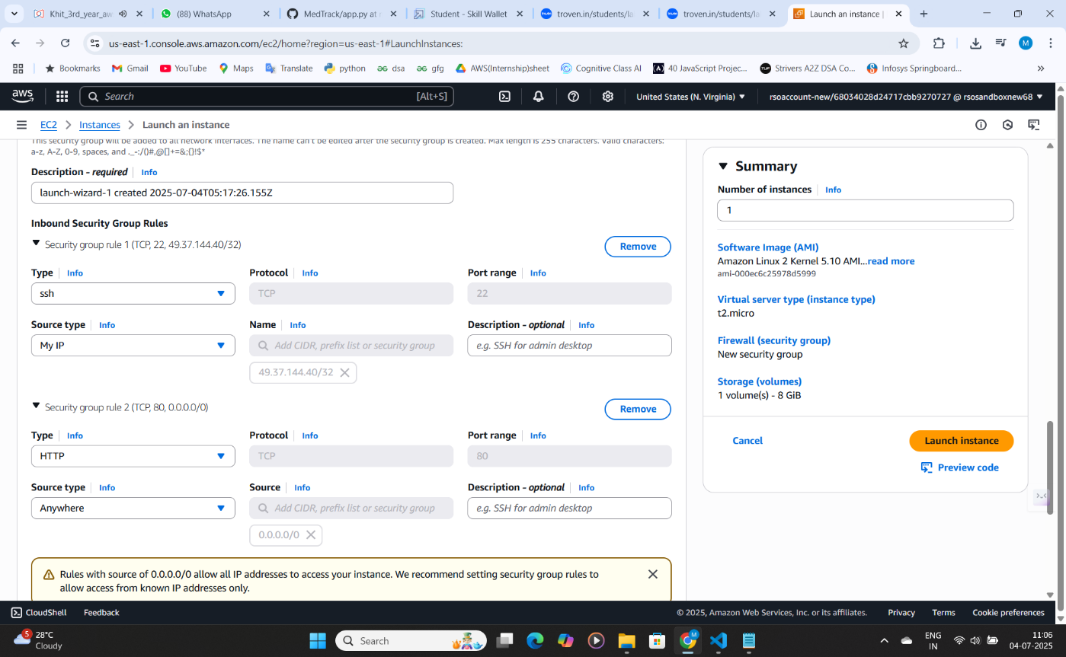

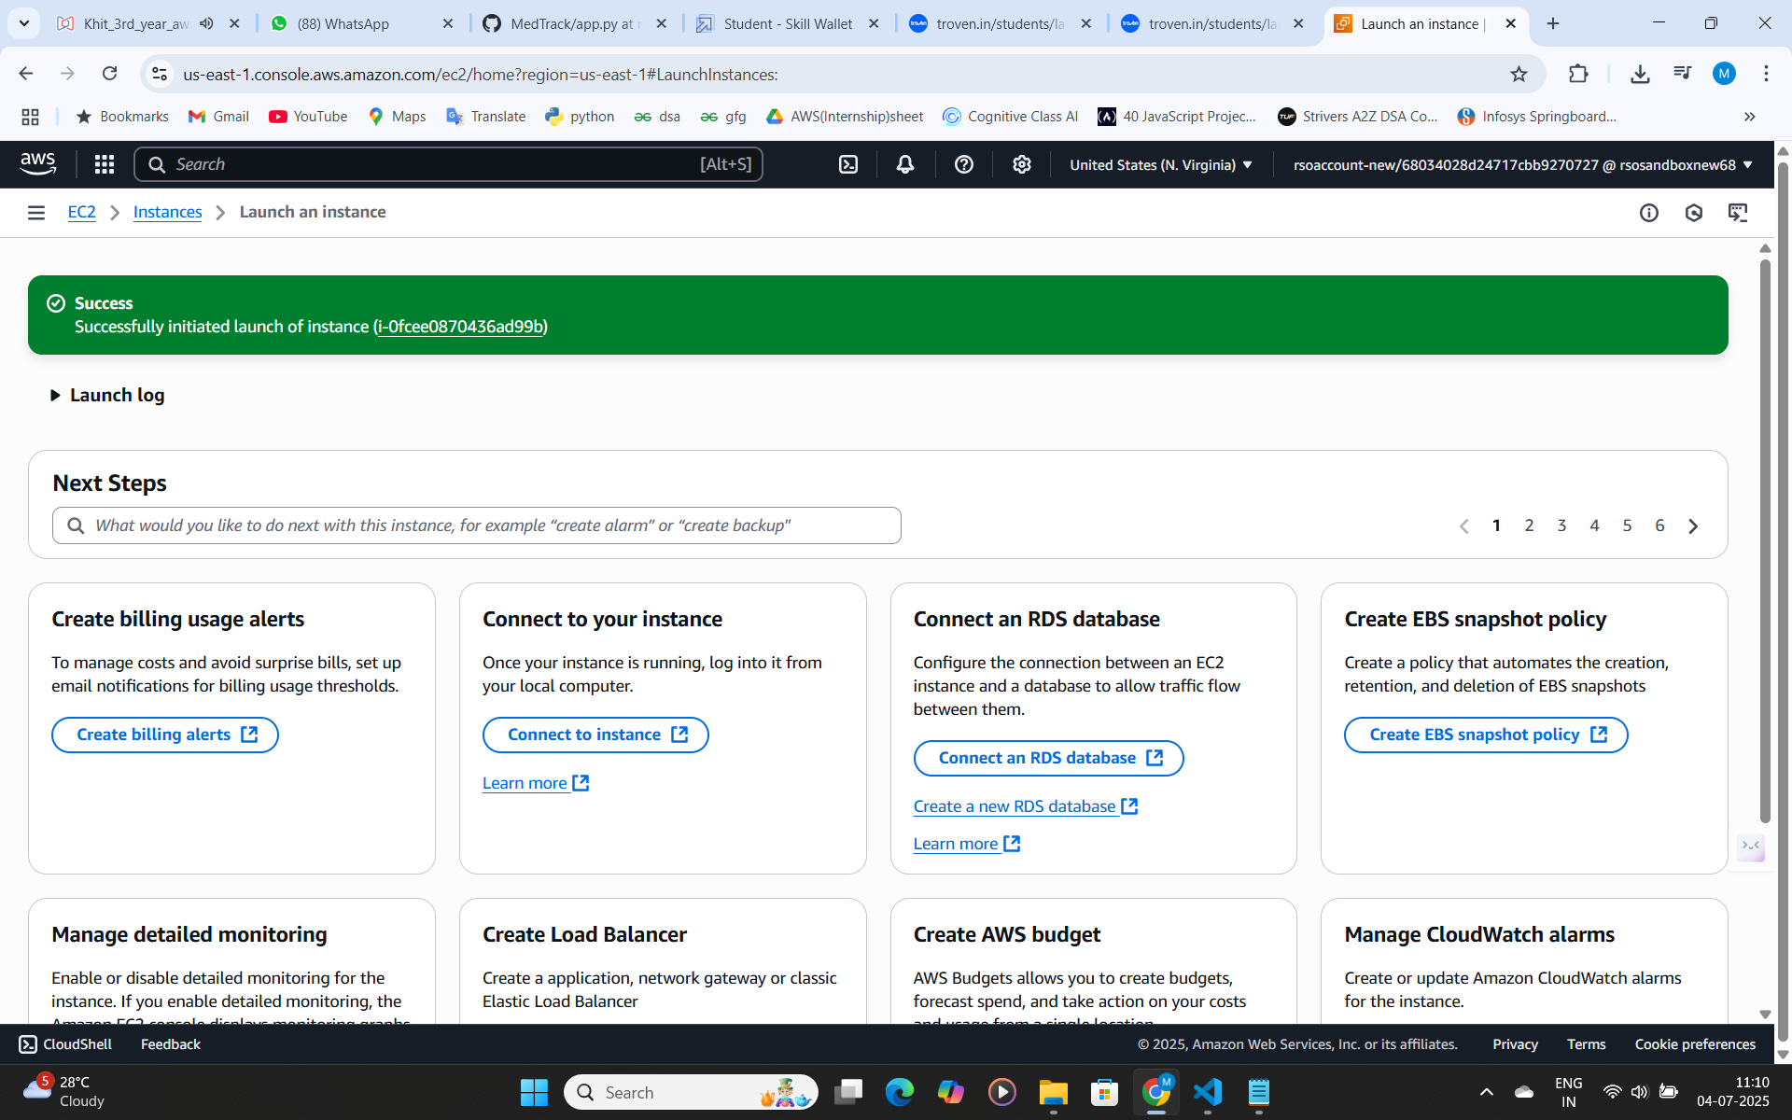

* 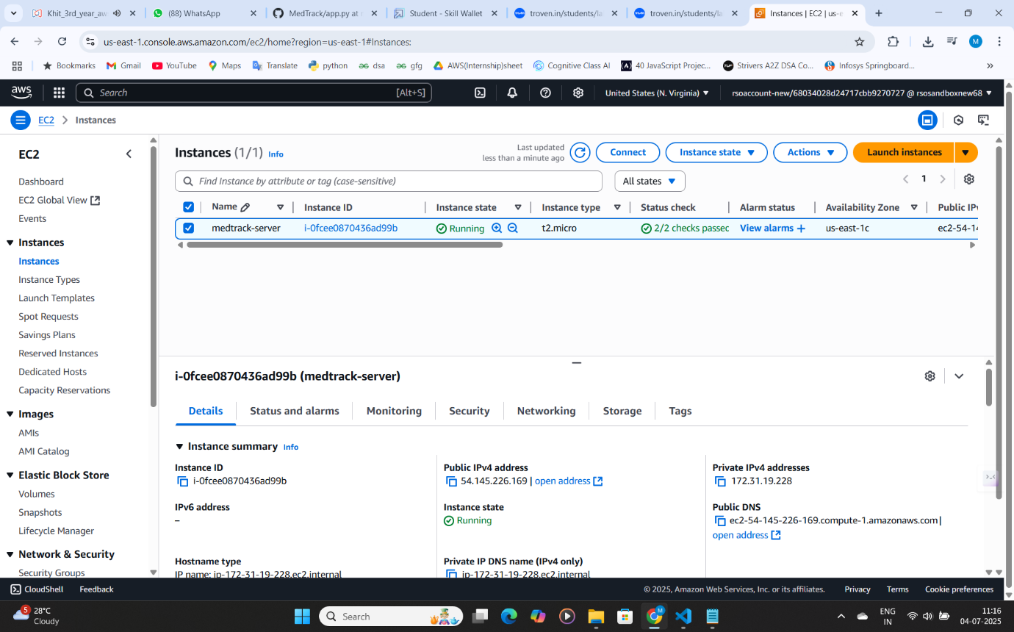To connect to EC2 using **EC2 Instance Connect,** start by ensuring that an **IAM role** is attached to your EC2 instance. You can do this by selecting your instance, clicking on **Actions**, then navigating to Security and selecting **Modify IAM Role** to attach the appropriate role. After the IAM role is connected, navigate to the EC2 section in the **AWS Management Console**. Select the EC2 instance you wish to connect to. At the top of the EC2 Dashboard,click the Connect button. From the connection methods presented, choose **EC2 Instance Connect**. Finally, click Connect again, and a new browser-based terminal will open, allowing you to access your EC2 instance directly from your browser.

To modify the **IAM role** for your EC2 instance:

1. Go to the **AWS IAM Console**, select **Roles**.
2. Click **Attach Policies**, then choose the required policies (e.g., **DynamoDBFullAccess**, **SNSFullAccess**) and click **Attach Policy**.
3. If needed, update the instance to use this modified role by selecting the EC2 instance, clicking **Actions**, then **Security**, and **Modify IAM role** to select the updated role.

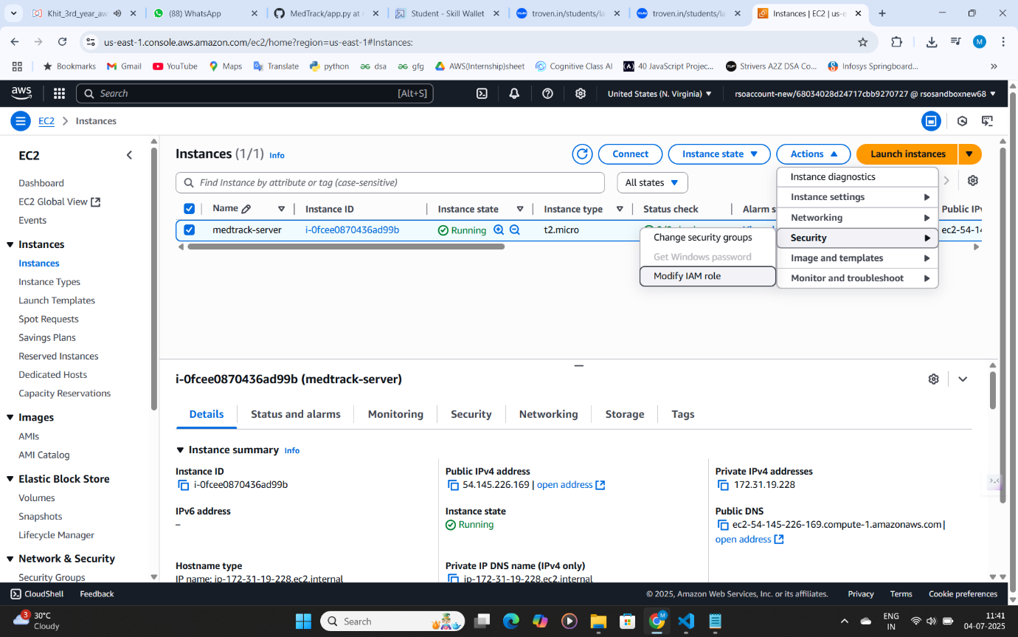

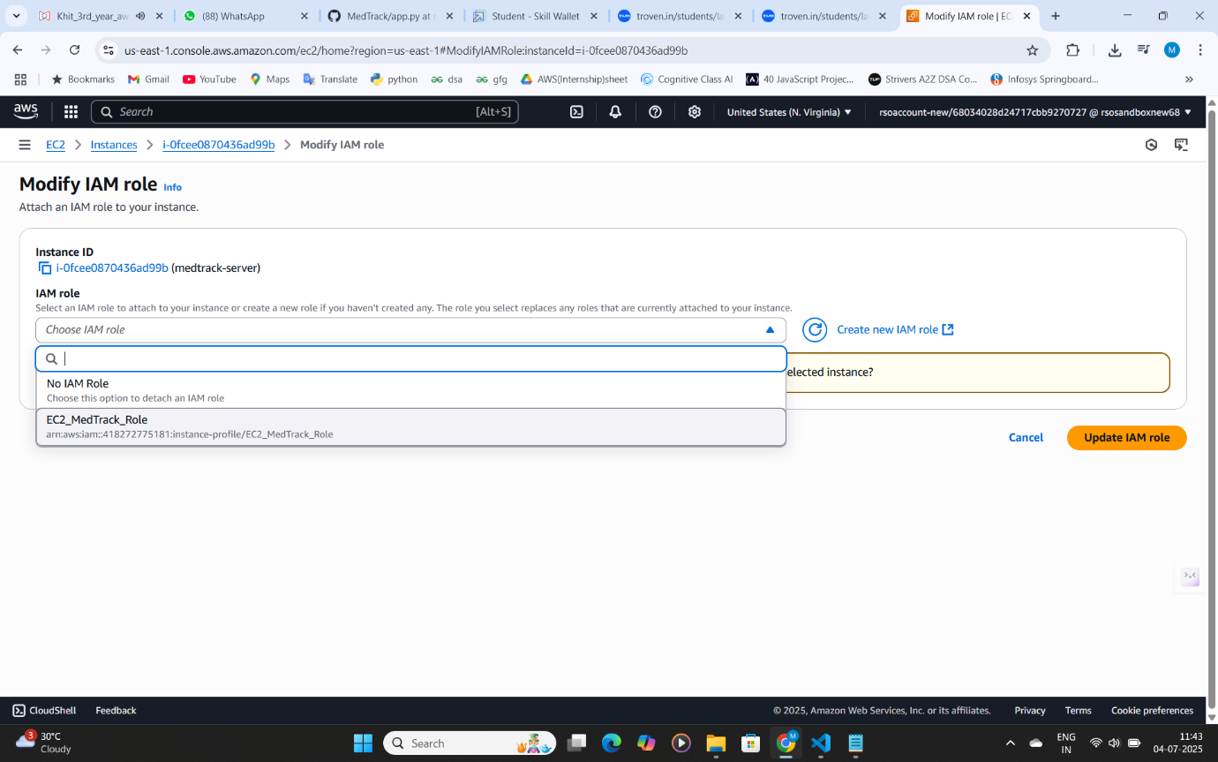

* Connect to your EC2 instance:

1. Go to the **EC2 Dashboard**, select your running instance, and click **Connect**.

* Now connect the EC2 with the files

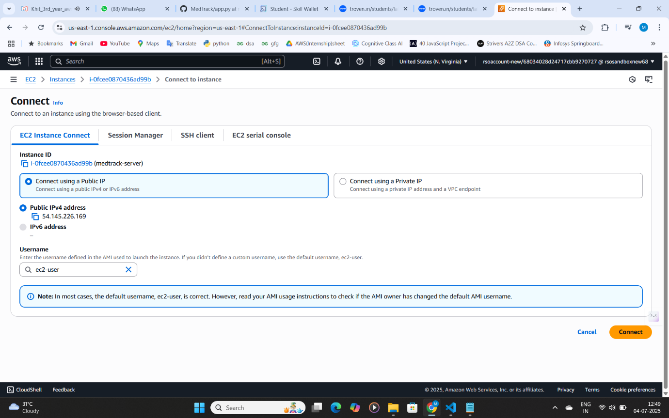

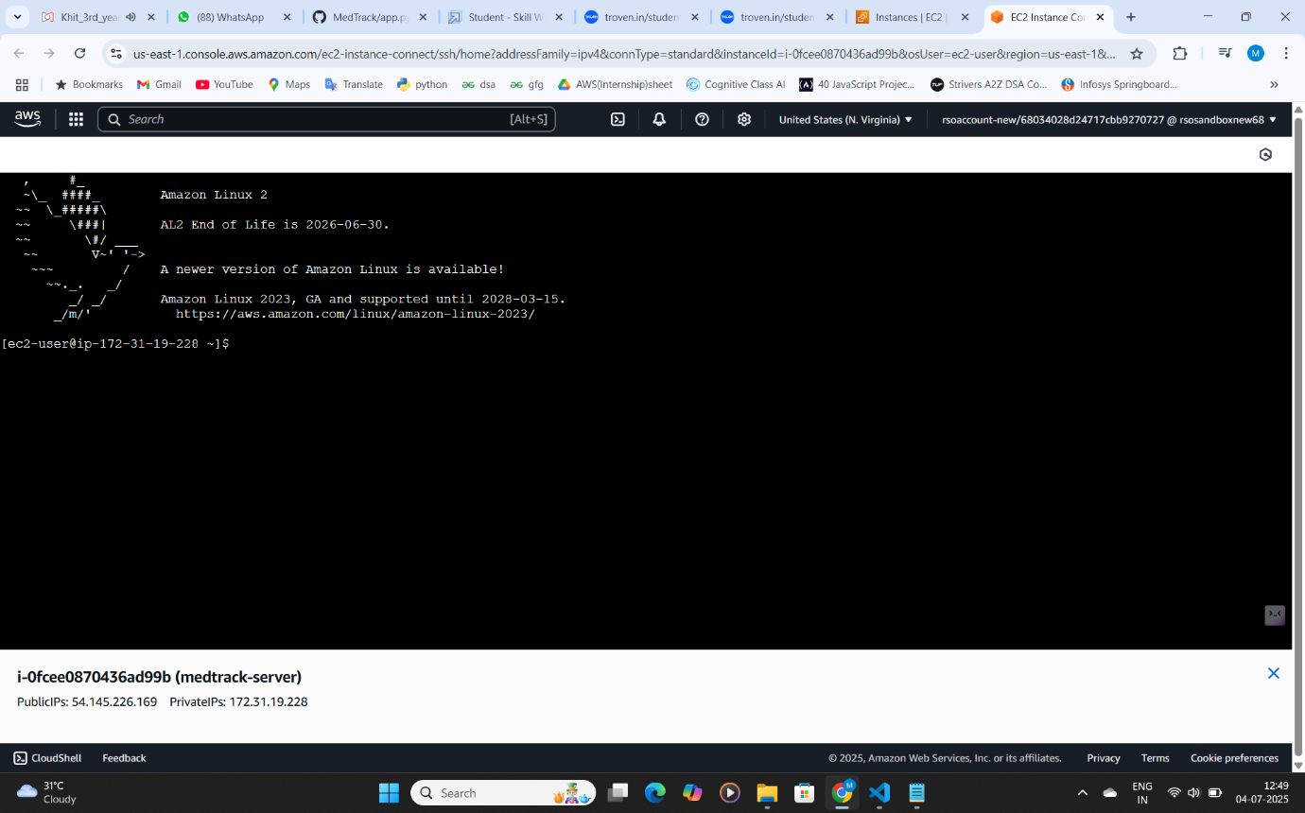

**Milestone 7: Deployment on EC2**

Deployment on an EC2 instance involves launching a server, configuring security groups for public access, and uploading your application files. After setting up necessary dependencies and environment variables, start your application and ensure it's running on the correct port. Finally, bind your domain or use the public IP to make the application accessible online.

**Activity 7.1: Install Software on the EC2 Instance**

**Install Python3, Flask, and Git:**

**On Amazon Linux 2:**

sudo yum update -y

sudo yum install python3 git

sudo pip3 install flask boto3

**Verify Installations:**

flask --version

git --version

**Activity 7.2:Clone Your Flask Project from GitHub**

**Clone your project repository from GitHub into the EC2 instance using Git.**

Run: ‘git clone <https://github.com/your-github-username/your-repository-name.git>’

Note: change your-github-username and your-repository-name with your credentials

here: ‘git clone https://github.com/Ravi-teja-777/medtrack_app.git

* This will download your project to the EC2 instance.

**To navigate to the project directory, run the following command:**

cd MedTrack

**Once inside the project directory, configure and run the Flask application by executing the following command with elevated privileges:**

**Run the Flask Application**

sudo flask run --host=0.0.0.0 --port=5000

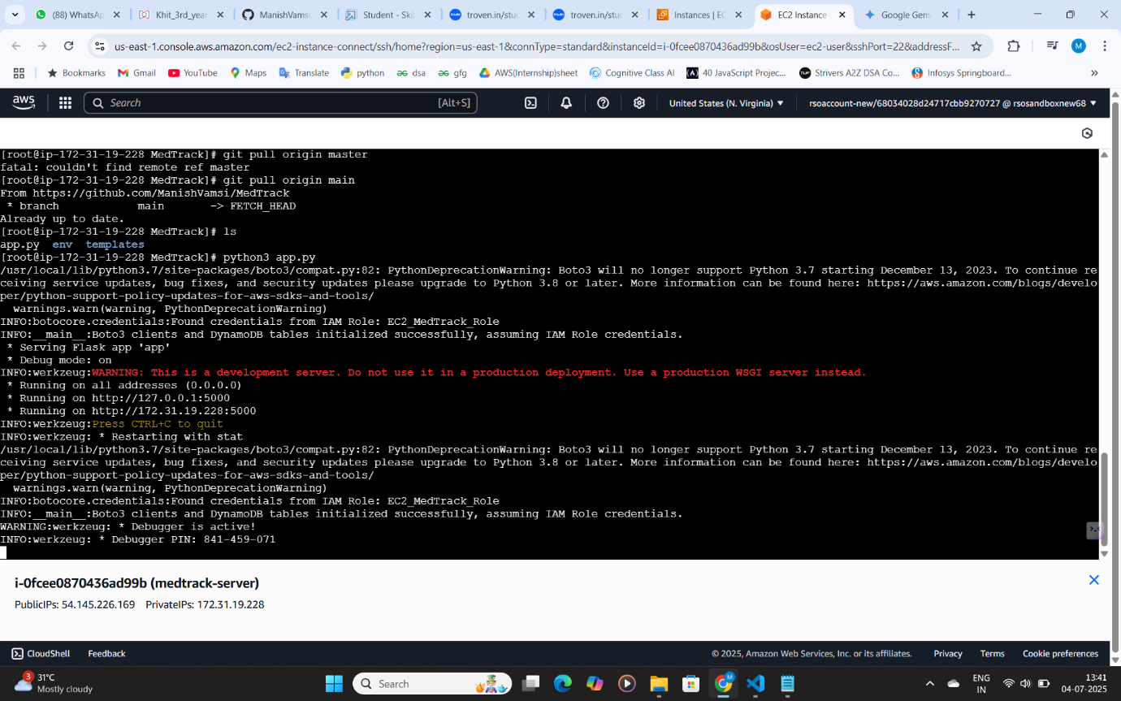

**Verify the Flask app is running**:

http://your-ec2-public-ip

* Run the Flask app on the EC2 instance

**Access the website through:**

**Public-IPs:** [**https://54.145.226.169:5000**](https://54.145.226.169:5000)/

**Milestone 8: Testing and Deployment**

● **Activity 8.1: Conduct functional testing to verify user registration, login, book requests, and notifications.**

**Functional testing to verify the project**

**Home Page:**  
The Home Page of your project is the main entry point for users, where they can interact with the system. It typically includes:

1. Input Fields: For users to enter basic information like appointment requests, diagnosis submissions, or service bookings.
2. Navigation: Links to other sections such as the login page, dashboard, or service options.
3. Responsive Design: Ensures the page is accessible across devices with a clean, user-friendly interface.

The Home Page serves as the initial interface that directs users to the key functionalities of your web application.

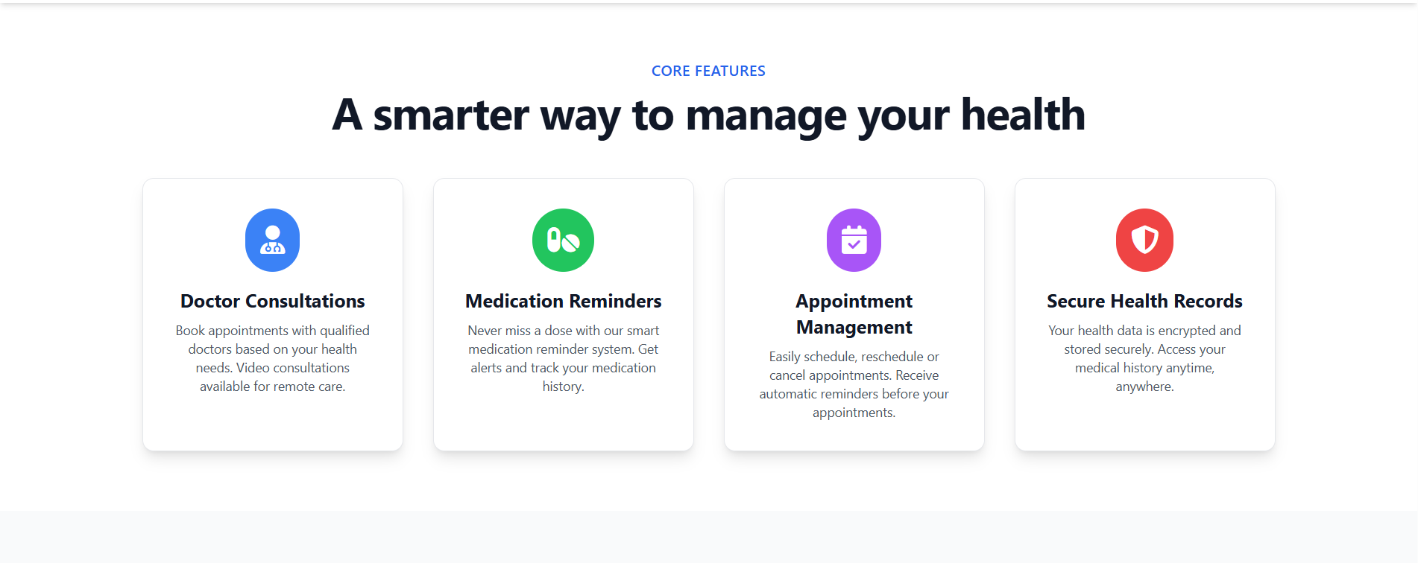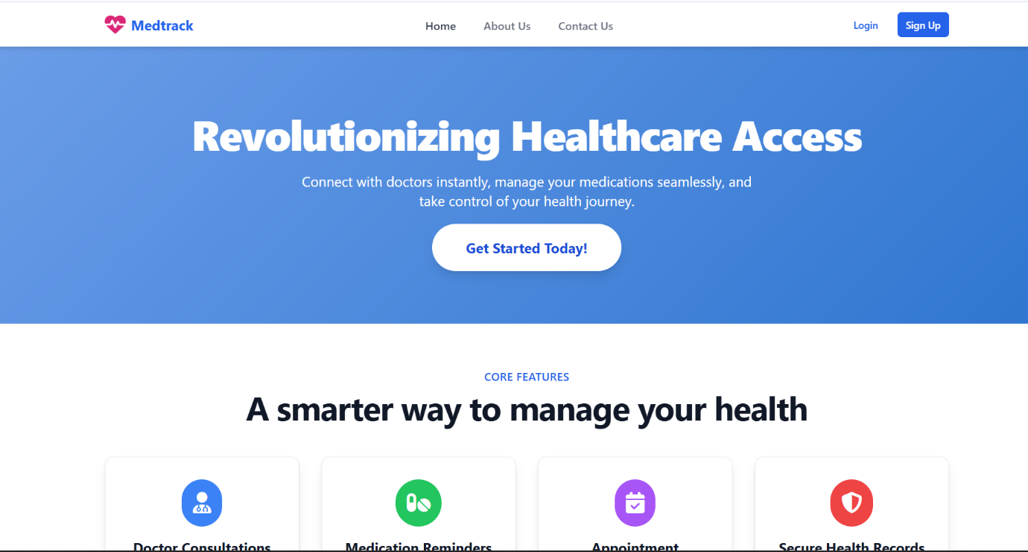

**DOCTOR AND PATIENT REGISTRATION PAGE:**

The Doctor Registration Page allows doctors to register and create an account on the platform. It typically includes:

1. Input Fields: For doctor details such as name, specialty, qualifications, and contact information.
2. Login Credentials: Fields for setting a username and password for secure access.
3. Submit Button: A button to submit the registration details, which will then be stored in the database after validation.

**PATIENT AND DOCTOR LOGIN PAGES:**

The Patient and Doctor Login Pages allow users to securely access their accounts on the platform. Each login page typically includes:

1. Username and Password Fields: Users enter their credentials (username and password) to authenticate their account.
2. Login Button: A button to submit login details and validate user access.

Once logged in, patients and doctors are redirected to their respective dashboards to manage appointments, medical records, and other relevant tasks.

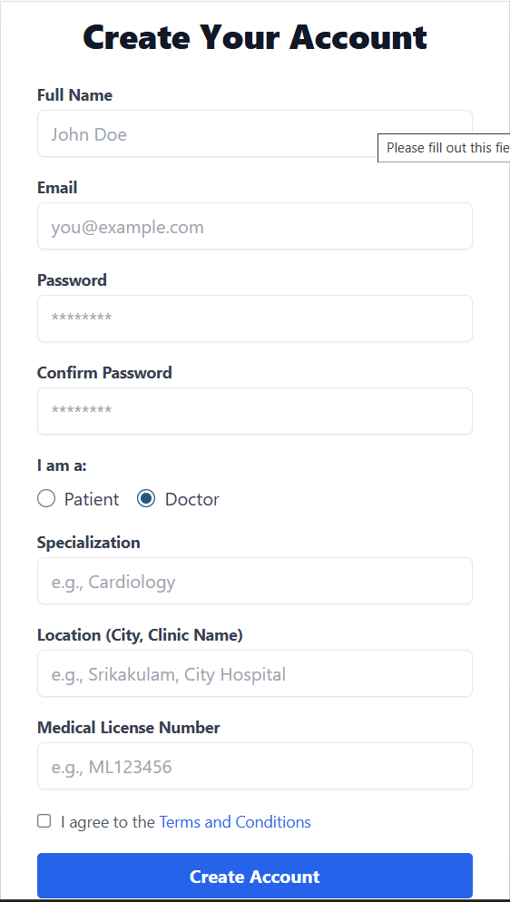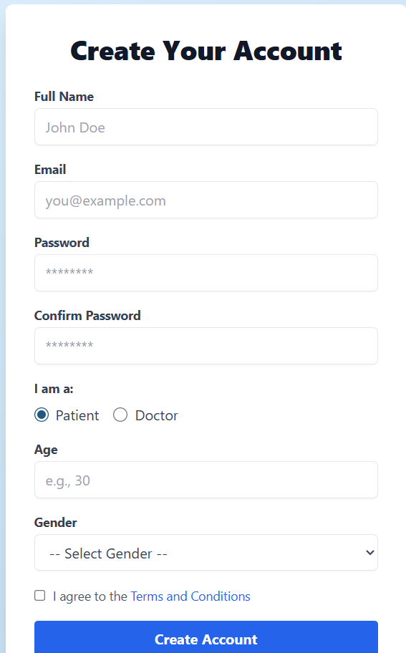

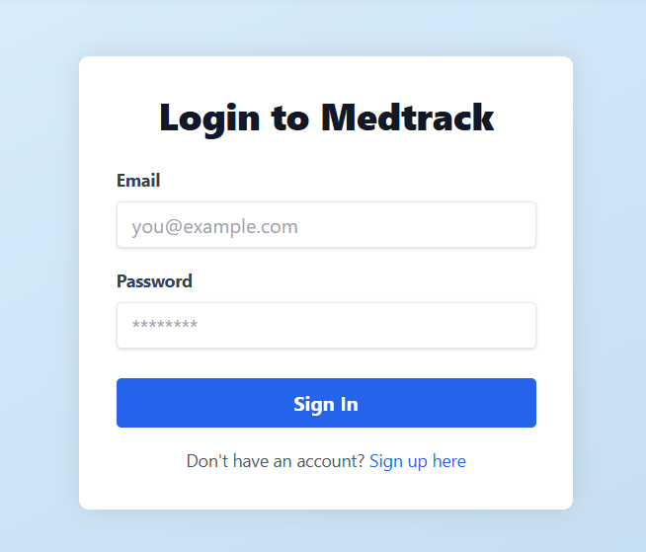

**User Dashboard:**

The User Dashboard (for patients) provides an easy interface to manage appointments and track their status. It typically includes:

1. Book Appointment Section: A form for selecting a doctor, choosing an appointment time, and submitting the request.
2. Appointment Status: A section showing the current status of appointments (e.g., confirmed, pending, or completed) with options to view details or cancel.
3. Medication Remainders: Patients can easily set up personalized reminders for their medications, including dosage, frequency, and specific times.

This dashboard helps patients book new appointments and keep track of their healthcare schedules.

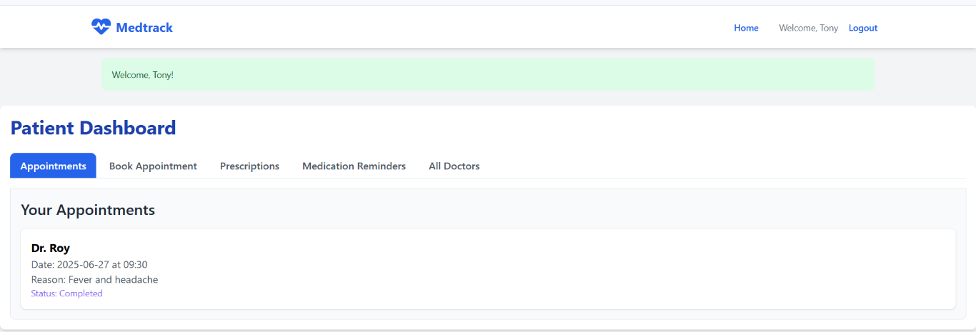

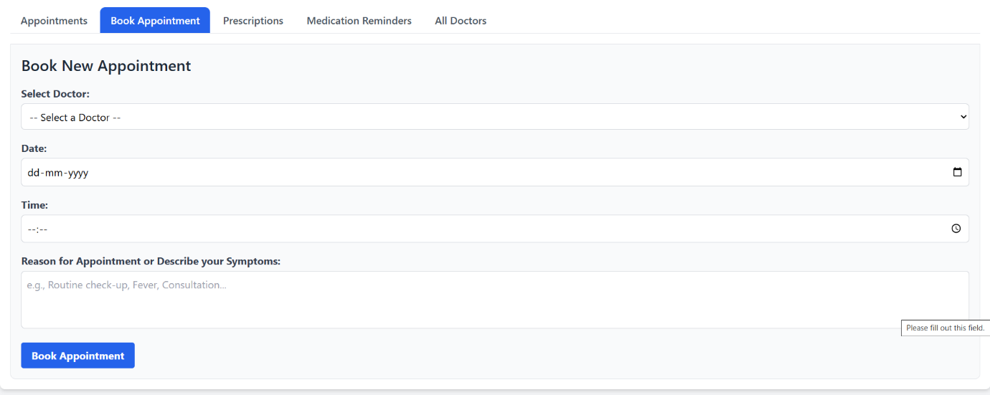

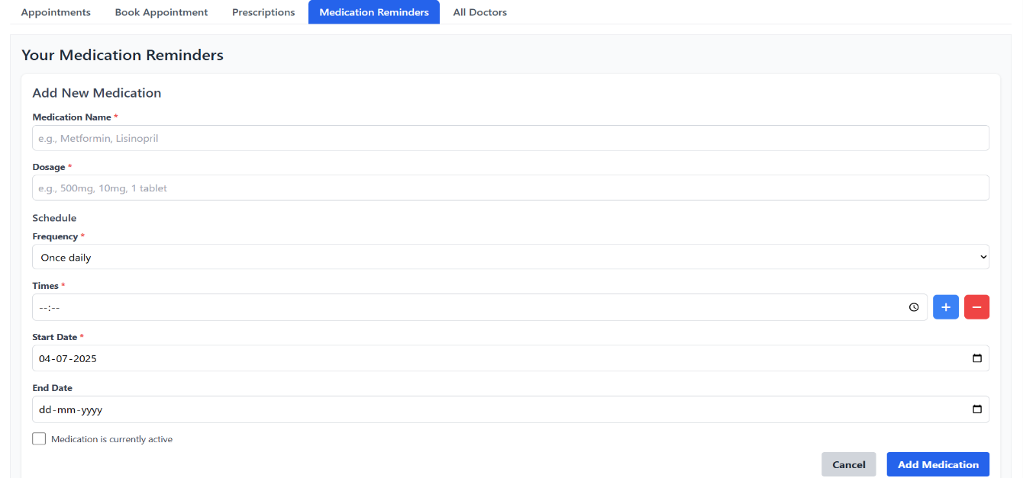

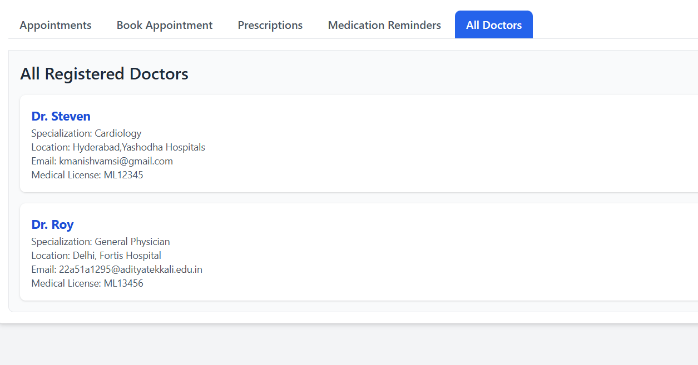

**Doctor Dashboard:**

The **Doctor Dashboard** provides doctors with a comprehensive view of their upcoming appointments and patient details. It typically includes:

1. **Upcoming Appointments List**: A table or list showing patient names, appointment times, and appointment statuses (e.g., confirmed, pending).
2. **Patient Details**: Quick access to each patient's medical history, contact information, and previous visit records.
3. **Appointment Actions**: Options to view, confirm , or cancel appointments, ensuring efficient management.

The dashboard serves as the main interface for doctors to manage their schedules, track patient interactions, and provide timely care.

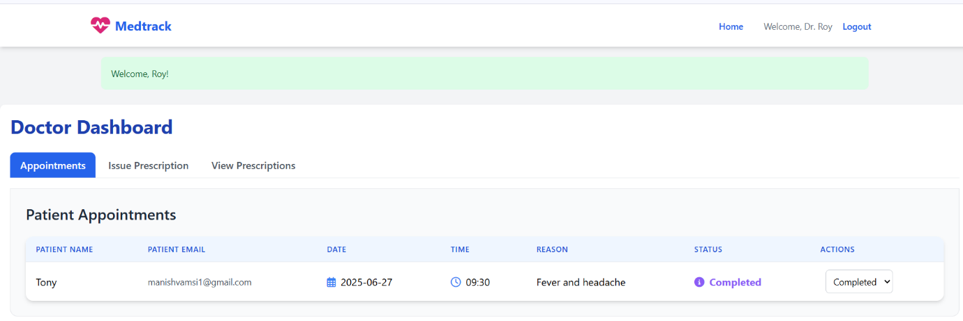

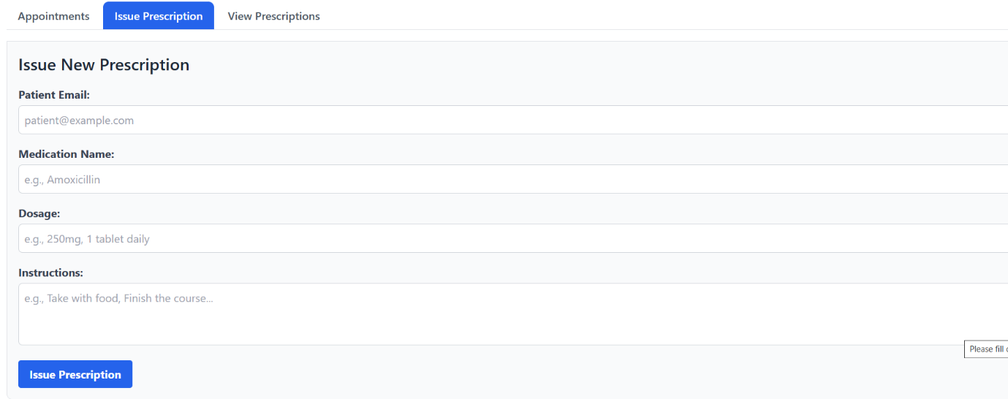

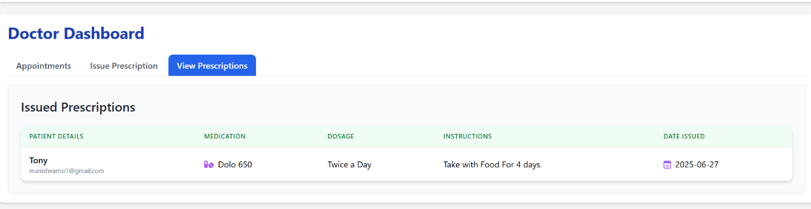

**DynamoDB Database:**

1. **medtrack_users:**

This table stores all user profiles for the Medtrack application, including patient and doctor accounts. It contains essential login credentials, personal details, and user-specific attributes like specialization or age.

1. **medtrack_appointments:**

This table is dedicated to managing all scheduled medical appointments within the system. It records details such as the patient, doctor, date, time, reason for visit, and the current status of each appointment.

1. **medtrack_prescriptions:**

This table holds all digital prescriptions issued by doctors through the application. It details the prescribed medication, dosage, instructions, the prescribing doctor, and the patient it was issued for.

1. **medtrack_medication_reminders:**

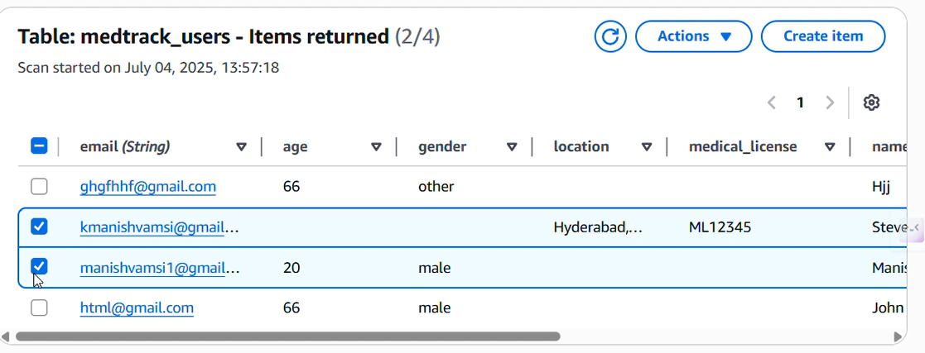This table stores personalized medication reminders set by patients to help them adhere to their treatment plans. It includes the medication name, dosage, frequency, times, and tracks whether a dose has been taken

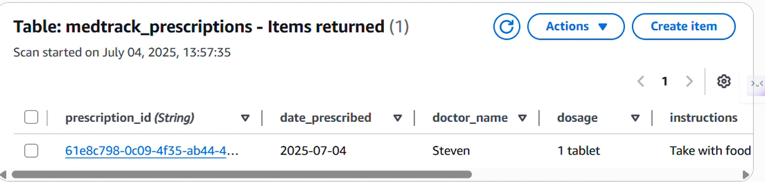

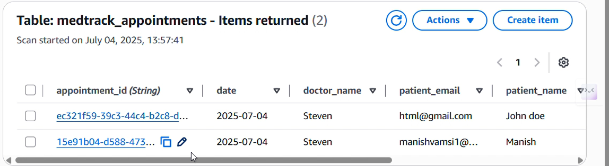

**Conclusion:**

The **MedTrack application** has been successfully developed and deployed using a robust cloud-based architecture tailored for modern healthcare environments. Leveraging AWS services such as EC2 for hosting, DynamoDB for secure and scalable patient data management, and SNS for real-time alerts, the platform ensures reliable and efficient access to essential medical tracking services. This system addresses critical challenges in healthcare such as managing patient records, monitoring medication schedules, and ensuring timely communication between healthcare providers and patients.

The cloud-native approach enables seamless scalability, allowing MedTrack to support increasing numbers of users and data without compromising performance or reliability. The integration of Flask with AWS ensures smooth backend operations, including patient registration, medication reminders, and health updates. Thorough testing has validated that all features—from user onboarding to alert notifications—function reliably and securely.

In conclusion, the MedTrack application delivers a smart, efficient solution for modernizing healthcare management, improving patient care, and streamlining communication between medical staff and patients. This project highlights the transformative power of cloud-based technologies in solving real-world challenges in the healthcare sector.